**Seminar Report**

**On**

**Multi-Page Responsive Website**

**(SMART SHOPPING CART)**

**Vagge Reema Rani**

**19261A04B9**

**MAHATMA GANDHI INSTITUTE OF TECHNOLOGY**

**ONLINE INTERNSHIP**

**EXPOSYS DATA LABS**

**WEB DEVELOPMENT**

**MULTI-PAGE RESPONSIVE WEBSITE**

**(SMART SHOPPING CART)**

**Report**

**TABLE OF CONTENTS**

**INDEX:**

* **ABSTRACT**
* **WEB DEVELOPING**
  + **Several Aspects of Web Developing**
  + **Process**
* **HARDWARE AND SOFTWARE REQUIREMENT**
  + **Hardware’s Required**
  + **Software’s Required**
* **TOOLS**
  + **Introduction**
  + **Features**
* **HTML**
* **CSS**
* **JAVASCRIPT**
* **SAVE WEB/HTML FORM DATA TO GOOGLE SHEETS**
* **SMART SHOPPING CART PROGRAM**
* **CONCLUSION**
* **REFERENCES**

**ABSTRACT**

The business-to-consumer aspect of an online shopping is the most visible business use of the World Wide Web. The primary goal of an online shopping site is to sell goods and services online. This project deals with developing an e-commerce website for online shopping. It provides the user with a catalogue of different goods and services available for purchase in the store. To facilitate online purchase a shopping cart is provided to the user. The system is implemented using a web browser as the front-end client. We used HTML, CSS, Java Script for developing this website. To develop an e-commerce website for online shopping, several Technologies must be studied and understood. This is a project with the objective to develop a basic website where a consumer is provided with a shopping cart application and to know about the technologies used to develop such an application. This document will discuss each of the underlying technologies to create and implement an e-commerce website for online shopping.

This paper presents a preliminary development of the smart shopping cart (SSC) that can be integrated into the smart mall system. The SSC can provide customers with the efficient user interface so that the shopping service can be effectively promoted. In the current design, with the function of face recognition on the user interface, the SSC can recognize the customer and further provide the associated assistive shopping information based on the purchase history.

The popularity of e-commerce is growing in leaps and bounds. More and more customers prefer to purchase products through online platforms. It is less-time taking, simple and can be done sitting or lying on the couch in a drawing room. In this situation, if you want to sell products online and accelerate business growth, a full-fledged development of a shopping cart is extremely essential. The experimental demonstration shows the effectiveness of the proposed SSC which interacts with the customer and provides efficient shopping service.

1. **WEB DEVELOPING**

Website is a collection of related web pages, inhaling multimedia content, typically identified with a common domain name, and published on at least one web server. A website may be sociable via a public Internet Protocol (II) network, such as the Internet, or a private local area network (LAN), by referencing a uniform resource locator (URL) that identifies the site.

Websites can have many functions, and can he used in various fashions, a website can be a personal website, commercial website for a company, a government website, or a non-profit organization website. Websites are typically dedicated to a particular topic or purpose, ranging from entertainment and social networking to providing news and education. All publicly accessible websites collectively constitute the World Wide Web, while private websites, such as a company’s website for its employees, are typically a part of an intranet.

Web development is a broad term for the work involved in developing a web site for the internet (World Wide Web) or an intranet (a private network). Web development can range from developing the simplest static single page of plain text so the most complex web-based internet applications (or just ‘web apps’) electronic businesses, and social network services. A more comprehensive list of tasks to which web development commonly refers, may include web engineering, web design, web content development, client liaison, client- side server-side scripting, web server and network security configuration, and- commerce development. Among web professionals, “web development” usually refers to the main non-design aspects of building web sites, writing markup and coding.

* 1. **Several Aspects of Web Developing**

Before developing a web site once should keep several aspects in mind like:

* What to put on the web site?
* Who will host it?
* How to make it interactive
* How to secure the source code frequently?
* Will the web site design display well in different browsers?
* Will the navigation menus be easy to use?
* Will the web site load quickly?
* How easily will the site pages print?

**1.2 Process**

These are the steps considered while developing webpage:

**Web Developing Process**

1. Decide Purpose
2. Planning
3. Designing
4. Gather Content
5. Building
6. Testing
7. Upload to Server
8. Marketing & Maintenance

**2. HARDWARE AND SOFTWARE REQUIREMENT:**

* 1. **Hardware’s Required:**

**TABLE 1-HARDWARES REQUIRED**

|  |  |
| --- | --- |
| **Number** | **Description** |
| 1 | Pentium 4, Window XP/Window 7 |
| 2 | 1. RAM |

**2.2 Software’s Required:**

**TABLE 2-SOFTWARES REQUIRED**

|  |  |
| --- | --- |
| **Number** | **Description** |
| 1 | Windows XP,7 |
| 2 | HTML |
| 3 | CSS |
| 4 | JavaScript |
| 5 | Bootstrap |
| 6 | Visual Studio |

**3. TOOLS**

**3.1 Introduction**

The Translate and Edit application had been planned to consist of two parts- front end and back-end development. The front-end is the part of the web that you can see and interact with (e.g., Client-side programming). While front-end code interacts with the user in real time, the back end interacts with a server to return user ready results. The front-end is a combination of HTML CSS and JavaScript coding. By using JavaScript, modifications of the design of a web page can be made immediately, however only temporary, and visible only by the user.

Normally the user would not have rights to modify web content dynamically on the server side Logically, administrators are the ones who deal with back-end modification of databases for example, as they often contain sensitive data which should not be available to sec or modify by the public. These front-end and back-end tools includes languages like HTML, CSS, JavaScript, PHP, MYSQL etc. We will discuss all these languages in brief as given below.

**3.2 Features**

* Web Page Assets, Resources, and Network Information
* Proofing and Auditing

**4. HTML**

**4.1** **Introduction**

HTML (Hyper Text Mark-Up Language) is what is known as a “mark-up language” whose role is to prepare write documents using formatting tags. The tags indicate how the document is presented and bow it links to other documents.

The World Wide Web (WWW for short), or simply the Web, is the worldwide network formed by all the documents (called “web pages”) which are connected to one another by Hyperlinks.

Web pages are usually organised around a main page, which acts as a hub for being other Pages with hyperlinks. This group of web pages joined by hyperlinks and centred around a main page is called a website.

The Web is a vast living archive composed of a myriad of web sites, giving people access to web pages that may contain formatted text, images, sound, video, etc.

**4.2 What is the Web?**

The Web is composed of web pages stored on web servers, which are machines that are constantly connected to the Internet, and which provide the pages that users request. Every web pope, and more generally any online resource, such as images, video, music, and animation, is associated with a unique address called a URL. The key element for viewing web pages is the browser, a software program which sands requests to wet servers, then processes the resulting data and displays the information as intended, based on instructions in the HTML page.

The most used browsers on the Internet include:

* Mozilla Firefox,
* Microsoft Internet explorer
* Netscape Navigator,
* Safari,
* Opera

**4.3 Versions Of HTML:**

HTML was designed by Tim Berners-Lee, at the time a researcher at CERN (Chinese Ecosystem Research Network), beginning in 1989. He officially announced the creation of the Web on Usenet in August 1991. However, it wasn’t until 1993 that HTML was considered advanced enough to call it a language (HTML was then symbolically christened HTML 1.0).

RFC 1866, dated November 1995, represented the first official version of HTML, called HTML. 2.0. After the brief appearance of HTML 3.0, which was never officially released, HTML, 3.2 became the official standard on January 14, 1997. The most significant changes to HTML 3.2 were the standardization of tables, as well as many features relating to the presentation of web pages.

On December 18, 1997, HTML 4.0 was released. Version 4.0 of HTML was notable for standardizing style sheets and frames. HTML version 4.01, which came out on December 24, 1999, made several minor modifications to HTML 4.0.

**Example**

<HTML>

<HEAD>

</HEAD>

<BODY>

<H5>THIS IS AN EXAMPLE</H5>

</BODY>

</HTML>

**5. CSS**

**5.1 What Is CSS?**

* CSS stands for Cascading Style Sheets.
* CSS describes how HTML elements are to be displayed on screen, paper, or in other Media.
* CSS saves a lot of work. It can control the layout of multiple web pages all at once
* External stylesheets are stored in CSS files.
* CSS describes how HTML elements should be displayed.
* CSS Saves a Lot of Work! The style definitions are normally saved in external.css files.
* With an external stylesheet file, we can change the look of an entire website by changing Just one file!
* CSS can be either external or internal.

**5.2 CSS Syntax:**

A CSS ruleset consists of a selector and a declaration block:

CSS selector. The selector points to the HTML element you want to style.

The declaration block contains one or more declarations separated by semicolons.

Each declaration includes a CSS property name and a value, separated by a colon. A CSS declaration always ends with a semicolon, and declaration blocks are surrounded by curly braces.

The External CSS can be declared in the required HTML page as:

<link rel=”stylesheet” href=”CSS_file_name.css”>

The External CSS file is saved by using the .css extension, whereas the internal CSS is saved in corresponding HTML file using the <style> tag. Using External CSS is much better than using Internal. Here are a few reasons this is better.

* Easier Maintenance
* Reduced File Size
* Reduced Bandwidth
* Improved Flexibility

The selectors that can be used to select the HTML part are

* Id selector
* Class selector

**5.2.1 Id Selector:**

The id selector uses the id attribute of an HTML element to select a specific element. The id of an element should be unique within a page, so the id selector is used to select one unique element! To select an element with a specific id, write a hash (6) character, followed by the id of the element. The style rule below will be applied to the HTML element with id "para1":

**Example: -**

Suppose the HTML content is as follow,

<hl id="para1">content</h1>

Then Id will be declared as

#Paral{

text-align: center;

color: blue;

font-family: jokerman;

}

**5.2.2 The class Selector:**

The class selector selects elements with a specific class attribute.

To select elements with a specific class, write a period () character, followed by the name of the class.

**Example-**

.para1

{

text-align: center;

color:blue;

font-family: Jokerman;

}

**5.3 CSS Comments:**

Comments are used to explain the code and may help when you edit the source code later. Comments are ignored by browsers. A CSS comment starts with /* and ends with */ Comments can also span multiple lines.

**Example-**

.para1

{

text-align: center;

color:blue;

font-family: Jokenman; /*this is the single line comment*/

}

In the example above, all HTML elements with class=para1” will be blue and centre aligned.

**5.4 CSS Styles:**

* Background properties
* Border properties
* Padding
* Margin
* Colour
* Font properties
* Text properties link properties/Navigation bar properties

**6 JAVASCRIPT:**

**6.1 What is JavaScript?**

JavaScript is an object-based scripting language that is lightweight and cross-platform JavaScript is not compiled but translated. The JavaScript Translator (embedded in browser) is responsible to translate the JavaScript code.

It is mainly used for

* Client-side validation
* Dynamic drop-down menus.
* Displaying data and time.
* Displaying popup windows and dialog boxes (like alert dialog box, confirm dialog box and prompt dialog box).
* Displaying clocks etc.

**Example of JavaScript-**

<h2>Welcome to JavaScript/h2>

<script>

document.write(“Hello JavaScript by JavaScript”);

</script>

Here, <script> tag is used to initialize the script and document.write() is a function used to write. Like CSS, JavaScript also can be placed in:

1. Between the body tag of html
2. In .js file (external javaScript)
3. Between the head tag of html

**6.1.1 JavaScript Example: code between the body tag -**

In the given example, we have displayed the dynamic content using JavaScript. Let’s see the simple example of JavaScript that displays alert dialog box.

<script type=”text/javascript”>

alert(“Hello Javatpoint”);

</script>

**6.1.2 JavaScript Example: code in .JS file-**

* message.js file

function msg()

{

alert(“Hello Javatpoint”);

}

* Index.html

<head>

<script type=”text/javascript” src=”message.js”></script>

</head>

<body>

<p>Welcome to JavaScript</p>

<form>

<input type=”button” value=”click” onclick=”msg()”/>

</form>

</body>

We can create external JavaScript file and embed it in many html pages.

It provides code re usability because single JavaScript file can be used in several html pages. An external JavaScript file must be saved by ‘js’ extension. It is recommended to embed all JavaScript files into a single file. It increases the speed of the webpage.

**6.1.3 Between the head tag of html**

In the example given below, we are having a function message) which is called. To create a function, we use function name with keyword function. For function call, we need to have an Event.

**Example-**

<head>

<script type=”text/javascript”>

function msg()

{

alert(“Hello Javatpoint”);

}

</script>

</head>

<body>

<p>Welcome to JavaScript</p>

<form>

<input type=”button” value=”click” onclick=”msg()“/>

</form>

</body>

**6.2 How to Change Content of HTML using a JavaScript?**

One of many JavaScript HTML methods is getElementById().

This example uses the method to “find” an HTML element (with id=”demo”) and changes the element content (innerHTML) to “Hello JavaScript”:

**Example-**

document.getElementById(“demo”).innerHTML=”Hello JavaScript”;

document.getElementById(“demo”).style.fontSize=”25px”;

<html>

<head>

<script>

function myFunction()

{

document.getElementById(“demo”).innerHTML = “Paragraph Changed.”;

}

</script>

</head>

<body>

<h1>My Web Page</h1>

<p id=”demo”>A Paragraph</p>

<button type=”button” onclick=”myFunction()”>Try it</button>

</body>

</html>

**6.3 Comments in JavaScript:**

The JavaScript comments are meaningful way to deliver message. It is used to add information about the code, warnings, or suggestions so that end user can easily interpret the code. The JavaScript comment is ignored by the JavaScript engine i.e., embedded in the browser

**6.4 Advantages of JavaScript comments:**

There are mainly two advantages of JavaScript comments:

* **To make code easy to understand:** It can be used to elaborate the code so that end user can easily understand the code.
* **To avoid the unnecessary code:** It can also be used to avoid the code being executed. Sometimes, we add the code to perform some action. But after some time, there may be need to disable the code. In such case, it is better to use comments.

**Example-**

<script type=”text/JavaScript”>

function msg()

{

alert(“Hello Javatpoint”); /* this is a comment*/

}

</script>

**6.5 JavaScript Variable:**

A JavaScript variable is simply a name of storage location. There are two types of variables in JavaScript: local variable and global variable. There are some rules while declaring a JavaScript variable (also known as identifiers).

* Name must start with a letter (a to z or A to Z), underscore), or dollar ($) sign.
* After first letter we can use digits (0 to 9), for example value1.

JavaScript variables are case sensitive, for example x and X are different variables.

**6.6 JavaScript Form Validation:**

It is important to validate the form submitted by the user because it can have inappropriate Values. So, validation is must

The JavaScript provides you the facility the validate the form on the client side so processing will be fast than server-side validation. So, most of the web developers prefer JavaScript form validation.

Through JavaScript, we can validate name, password, email, date, mobile number etc fields.

**Example-**

<script>

function validateform()

{

var name=document.myform.name.value;

var password=document.myform.password.value;

if (name==null || name==””)

{

alert(“Name can’t be blank”);

return false;

}

else if(password.length<6)

{

alert(“Password must be at least 6 characters long.”)

return false;

}

}

</script>

<body>

<form name=”myform” method=”post” action=”abc.jsp” onsubmit=”return validate for m()”>

Name: <input type=”text” name=”name”><br>

Password: <input type=”password” name=”password”><br>

<input type=”submit” value=”register”>

</form>

</body>

In this example, we are going to validate the name and password. The name can’t be empty, and password can’t be less than 6 characters long Here, we are validating the form on form submit.

The user will not be forwarded to the next page until given values are correct.

**6.7 JavaScript Retype Password Validation:**

<script type=”text/javascript”>

function matchpass()

{

var firstpassword = document.fl.password.value;

var secondpassword = document.fl.password2.value;

if (firstpassword==secondpassword)

{

return true;

}

else

{

alert(“password must be same!”)

return false;

}

</script>

<form name=”f1” action=”register.jsp” onsubmit=”retum matchpass()”>

Password:<input type=”password” name=”password” /><br/>

Re-enter Password <input type=”password” name=”password”/><br>

<input type=”submit”>

</form>

**6.8 JavaScript Functions:**

JavaScript functions are used to perform operations. We can call JavaScript function many Times to reuse the code.

**6.8.1 Advantage of JavaScript function**

There are mainly two advantages of JavaScript functions.

* Code reusability
* Less coding

**6.8.2 JavaScript Function Syntax**

The syntax of declaring function is given below.

function functionName([arg1, arg2,argN])

{

//Code to be executed

}

JavaScript Functions can have () or more arguments.

**Example-**

<script>

function msg()

{

alert(“hello! This is message”);

}

</script>

<input type=”button” onclick=”msg()” value=”call function”/>

**Output of the above example:**

Hello! This is message

**6.9 JavaScript Control Statements:**

**6.9.1 If-else:**

It evaluates the content whether condition is true or false. The syntax of JavaScript if-else statement is given below.

if(expression)

{

//Content to be evaluated if condition is true

}

else

{

//content to be evaluated if condition is false

}

**Example-**

<script>

var a=20;

if(a%2==0)

{

document.write(“a is even number”);

}

else

{

document.write(“a is odd number”);

}

</script>

**6.9.2 JavaScript Switch:**

The JavaScript switch statement is used to execute one code from multiple expressions. It is just like else if statement that we have learned in previous page. But it is convenient than if……else……if because it can be used with numbers, characters etc. The signature of JavaScript switch statement is given below.

Switch(expression){

case value1:

code to be executed;

break;

case value2:

code to be executed;

break;

default: code to be executed if above values are not matched;

}

**7. Save Web/HTML Form Data to Google Sheets**

This article uses our product API Spreadsheets, which our users say is the easiest way to save web/html form data to Google Sheets. It has a generous free tier.

If you are like us and often create websites where nothing needs a server and a database except a few forms, then you must also get frustrated with all the extra work you have to do to simply save data from a few fields.

Step 1: Set up a contact form in an HTML file or through Google Form

Okay, if you don’t know any HTML, then this might be a steep learning curve. The example is small so you should Google terms you don’t understand and it might make sense.

Let’s create a form in HTML. It’s a basic contact form and doesn’t contain any styling.

The form will look like this

The full code for the Contact Form and how to handle the submission is below.

Open a blank file in the text editor you use for programming, copy, and paste the code below and save the file with a [.html] extension. We saved ours as ContactForm.html

We will walk through the HTML part now and the JavaScript part later.

The contact form has 4 fields.

Pay attention to the name attribute of the <input> tags. These will be the column headers of our spreadsheet we save the data in, and they MUST match up.

We are going to name the four input tags as follows. The lines refer to the line of code:

1. Full_name, line 29 This will be a text field with the full name of the person
2. Email, line 33 This will be a text field with the email of the person
3. Age, lines 37–38 This will be a radio selection field with two age options. 18–35 and 35+. We will denote them in the value attribute of the radio fields
4. Message, line 42 This will be a text area that will contain the message the person types

All four <input> tags will be inside a <form> tag (line 26) that we will give an id attribute of my Form. Do not give it any other id as the data submission to spreadsheet function that we will write later in the JavaScript is dependent on it.

Finally, our main component will be a <button> (line 47) that will be submitting the data. In its onclick attribute we are going to specify the function SubForm().

Again, do not give the function another name as we will be writing this exact function later in Javascript to handle submitting the data.

**8. Smart Shopping Cart Program.**

I have created Smart Shopping Cart using the following code.

**8.1 Index Page (index.html)**

<!DOCTYPE html>

<html>

<head>

    <meta charset="utf-8">

    <meta http-equiv="X-UA-Compatible" content="IE=edge">

    <meta name="viewport" content="width=device-width, initial-scale=1">

    <title>Creating Website</title>

    <!-- Latest compiled and minified CSS -->

<link rel="stylesheet" href="https://cdn.jsdelivr.net/npm/bootstrap@3.4.1/dist/css/bootstrap.min.css" integrity="sha384-HSMxcRTRxnN+Bdg0JdbxYKrThecOKuH5zCYotlSAcp1+c8xmyTe9GYg1l9a69psu" crossorigin="anonymous">

<!-- Optional theme -->

<link rel="stylesheet" href="https://cdn.jsdelivr.net/npm/bootstrap@3.4.1/dist/css/bootstrap-theme.min.css" integrity="sha384-6pzBo3FDv/PJ8r2KRkGHifhEocL+1X2rVCTTkUfGk7/0pbek5mMa1upzvWbrUbOZ" crossorigin="anonymous">

    <link rel="stylesheet" type="text/css" href="style.css">

    <link rel="stylesheet" type="text/css" href="https://cdnjs.cloudflare.com/ajax/libs/font-awesome/6.1.1/css/all.min.css">

</head>

<body>

    <nav class="nav nav_top">

        <div class="logo">

            <a href="#"><img src="pic2.jpg" width="150"></a>

        </div>

        <div class="nav_side">

            <a href="about.html">About Us</a>|

            <a href="service.html">Services</a>|

            <a href="blog.html">Blogs</a>|

            <a href="contact.html">Contact Us</a>|

            <a href="login.html">Login</a>|

            <a href="register.html">SignUp</a>

        </div>

    </nav>

    <div class="main">

        <div class="main_content">

            <h2>New arrivals every week<br>

                <span>Explore the new season On every products.Enjoy speedy delivery.Express delievery available,plus free returns globally.Check Out Our Wide Range of New Arrivals in Stock Now. Order Online Today! The UK's Largest Independent Clothing Retailer. Shop Our Range Today!.Myntra is a major Indian fashion e-commerce company headquartered in Bengaluru, Karnataka, India.[1] The company was founded in 2007 to sell personalized gift items. In May 2014, Myntra.com was acquired by Flipkart.

                In May 2022, Myntra launched an express delivery service on its app to offer one of a kind of experience by fashion & beauty platform. This service allow shoppers to receive their orders for products marked with ‘M-express tag’ on the listing page within 24-48 hours of purchase.Established by Mukesh Bansal along with Ashutosh Lawania and Vineet Saxena; Myntra sold on-demand personalized gift items. It mainly operated on the B2B (business-to-business) model during its initial years. Between 2007 and 2010, the site allowed customers to personalize products such as T-shirts, mugs, mouse pads, and others.Show has eight episodes of reality series which will see 10 contenders competing with each other. They would also be mentored and judged by a star studded jury, from the world of Bollywood, TV and fashion, including Bollywood diva Sonakshi Sinha and leading celebrity stylist, Shaleena Nathani.

                </span>

            </h2>

            <div class="btn">

                <a href="service.html">Book Now</a>

            </div>

            <br>

            <br>

        </div>

    </div>

    <div class="product">

        <h2>OUR PRODUCTS</h2>

        <div class="product_container">

            <div class="item">

                <div class="item_img">

                    <img src="pic4.jpg">

                </div>

                <div class="item_content">

                    <h3>Bouquet</h3>

                    <p>Bright and happy sunflowers, iris and tulips in a glass vase. The perfect arrangement to say get well or to wish good cheer. Tulip color options: red, white, pink, purple and yellow. Contact us for a custom variation of this bouquet.Price includes San Francisco delivery. </p>

                <a href="">Buy Now</a>

                <br>

                <br>

                <br>

                </div>

            </div>

            <div class="item">

                <div class="item_img">

                    <img src="pic3.jpg">

                </div>

                <div class="item_content">

                    <h3>Braid Indoor/Outdoor</h3>

                    <p>The Sun splash Collection of braided rugs combine form and function. Manufactured with modern machinery using 100% polypropylene material, it is durable and feels comfortable underfoot. The vibrant and modern color scheme nicely fits well with any contemporary decor </p>

                <a href="">Buy Now</a>

                <br>

                <br>

                <br>

                </div>

            </div>

            <div class="item">

                <div class="item_img">

                    <img src="pic6.jpg">

                </div>

                <div class="item_content">

                    <h3>Red Dress</h3>

                    <p>The red dress effect is a phenomenon in which a woman wearing red clothing, such as a red dress, is perceived to be more beautifully appealing than she is when wearing other colours. </p>

                <a href="">Buy Now</a>

                <br>

                <br>

                <br>

                </div>

            </div>

        </div>

        <div class="product_btn">

            <a href="service.html">Explore Our Products</a>

        </div>

    </div>

     <hr>

    <div class="keypoint">

        <h2>OUR KEY HIGHLIGHTS</h2>

        <div class="key_container">

            <div class="key_content">

                <li>Myntra Kurta Sets</li>

                <li>Myntra Beauty</li>

                <li>Myntra Jewellery</li>

                <li>Myntra Teens Wear</li>

                <li>Myntra Flip-Flops</li>

                <li>Myntra Watches</li>

                <li>Myntra Haircare</li>

                <li>Myntra Trousers</li>

                <li>Myntra Bath Essentials</li>

            </div>

            <div class="key_img">

                <img src="pic7,jpg.jpg">

            </div>

        </div>

   </div>

   <hr>

<div class="testi">

    <h2>Our Clients</h2>

    <div class="testi_container">

        <div id="carousel-example-generic" class="carousel slide" data-ride="carousel">

  <!-- Indicators -->

  <ol class="carousel-indicators">

    <li data-target="#carousel-example-generic" data-slide-to="0" class="active"></li>

    <li data-target="#carousel-example-generic" data-slide-to="1"></li>

    <li data-target="#carousel-example-generic" data-slide-to="2"></li>

  </ol>

  <!-- Wrapper for slides -->

    <div class="carousel-inner" role="listbox">

        <div class="item active">

            <div class="item_img">

                <img src="pic8.jpg" alt=" ">

            </div>

            <div class="item_content">

                <h3>Red dress Products</h3>

                <p>It is awesome.It is so beautiful Color is somewhat on dull side, but it looks elegant. The dress hugs your so beautifully and big thing that it makes you <br>look a little slim..hahaha... Over all the fall, the stuff, stiching and all is perfecf. Just go for it</p>

            </div>

        </div>

        <div class="item">

            <div class="item_img">

                <img src="pic9.jpg" alt=" ">

            </div>

            <div class="item_content">

                <h3>Bouquet </h3>

                <p>Bouquet is a vibrant hue and instantly brings the room to life. Its nature-inspired style is a simple way to decorate your walls <br>and add a touch of Indianness to your space.</p>

            </div>

        </div>

        <div class="item">

            <div class="item_img">

                <img src="pic10.jpg" alt=" ">

            </div>

            <div class="item_content">

                <h3>Flip-Flops</h3>

                <p>Well fit & fabulous, but prices are still higher side, it was amazing comfort and quality is 👌👌👌 Go for it 👌, it was amazing comfort <br>and quality is 👌👌👌 Go for it 👌</p>

            </div>

        </div>

    </div>

  <!-- Controls -->

  <a class="left carousel-control" href="#carousel-example-generic" role="button" data-slide="prev">

    <span class="glyphicon glyphicon-chevron-left" aria-hidden="true"></span>

    <span class="sr-only">Previous</span>

  </a>

  <a class="right carousel-control" href="#carousel-example-generic" role="button" data-slide="next">

    <span class="glyphicon glyphicon-chevron-right" aria-hidden="true"></span>

    <span class="sr-only">Next</span>

  </a>

</div>

    </div>

</div>

<hr>

<div class="team">

    <h2>OUR TEAM</h2>

    <div class="team_container">

        <div class="team_video">

            <video controls>

                <source src="qt.mp4" type="video/mp4">

            </video>

        </div>

        <div class="team_content">

            <p>he Myntra.com management team includes Lalitha Ramani (Chief Product Officer and Senior Vice President), Raghu Krishnananda (Chief Technology Officer), and Amit Mathur (Vice President - Human Capital | Real Estate and Workplace | FDC). Get Contact Info for All Departments Myntra.com Org Chart Lalitha Ramani</p>

            <p>Myntra's Chief, Myntra Fashion, Chief Experience Officer (CXO) is Manohar Kamath. Myntra's key executives include Manohar Kamath and 2 others. Need Data? Craft can deliver 250+ data points of financial, operating, and human capital indicators on companies via API.</p>

            <p>He joined Myntra from Shoppers Stop, where he was the Chief Operating Officer & Director of the Board of Crossword Book Stores and Nuance (India)</p>

        </div>

    </div>

</div>

<div class="feed">

    <h2>Write a review</h2>

    <div class="feed_form">

        <form name="submit-to-google-sheet" method="post">

            <input type="text" name="Name" placeholder="Full Name" required><br>

            <input type="email" name="Email" placeholder="Email ID" required><br>

            <input type="number" name="Number" placeholder="Contact Number" required><br>

            <textarea rows="5" cols="7" name="Review" placeholder="Write your review"></textarea><br>

            <button type="Submit">Submit</button>

        </form>

    </div>

</div>

<hr>

<footer>

    <div class="logo">

        <a href="index.html"><img src="pic2.jpg" width="150" height="90px"></a>

    </div>

    <br>

    <br>

    <br>

    <div class="pages">

        <h3>Pages</h3>

        <a href="about.html">About Us</a>|

        <a href="service.html">Services</a>|

        <a href="blog.html">Blogs</a>|

        <a href="login.html">Login</a>|

        <a href="register.html">Sign Up</a>

    </div>

    <div class="doc">

        <h3>Documents</h3>

        <a href="about.html">Privacy Policy</a>|

        <a href="about.html">Terms of Use</a>|

        <a href="about.html">Refund Policy</a>

    </div>

    <div class="social">

        <h3>Follow us</h3>

        <a href="https://www.facebook.com/myntra"  target="_blank"><i class="fa-brands fa-facebook"></i></a>|

        <a href="https://www.linkedin.com/company/myntra/" target="_blank"><i class="fa-brands fa-linkedin"></i></a>|

        <a href="https://www.instagram.com/Myntra/" target="_blank"><i class="fa-brands fa-instagram-square"></i></a>|

        <a href="https://twitter.com/myntra"  target="_blank"><i class="fa-brands fa-twitter"></i></a>

    </div>

    <div class="contact">

        <h3>Contact Us</h3>

        <a href="tel: +919032420982"><i class="fa-brands fa-whatsapp"></i></a>|

        <a href="mailto: heyreema@gmail.com"><i class="fa-solid fa-phone"></i></a>|

        <a href="mailto: abc@gmail.com"><i class="fa-solid fa-square-envelope"></i></a>

    </div>

    <hr>

    <p>Copyright &copy;2022 aradhana. All rights reserved</p>

</footer>

 <!-- jQuery (necessary for Bootstrap's JavaScript plugins) -->

    <script src="https://code.jquery.com/jquery-1.12.4.min.js" integrity="sha384-nvAa0+6Qg9clwYCGGPpDQLVpLNn0fRaROjHqs13t4Ggj3Ez50XnGQqc/r8MhnRDZ" crossorigin="anonymous"></script>

<!-- Latest compiled and minified JavaScript -->

<script src="https://cdn.jsdelivr.net/npm/bootstrap@3.4.1/dist/js/bootstrap.min.js" integrity="sha384-aJ21OjlMXNL5UyIl/XNwTMqvzeRMZH2w8c5cRVpzpU8Y5bApTppSuUkhZXN0VxHd" crossorigin="anonymous"></script>

<script>

*const* scriptURL = 'https://script.google.com/macros/s/AKfycbxnTN1JSgXNzfsnqRLjVnhPYLf-gB2kZVbwcjXWbcG9yU7JwLdbuYLD8i-QMshUs_Ft/exec'

*const* form = document.forms['submit-to-google-sheet']

  form.addEventListener('submit', *e* *=>* {

    e.preventDefault()

    fetch(scriptURL, { method: 'POST', body: new FormData(form)})

      .then(*response* *=>* alert('Success!', response))

      .catch(*error* *=>* console.error('Error!', error.message))

  })

</script>

</body>

</html>

**Output:**

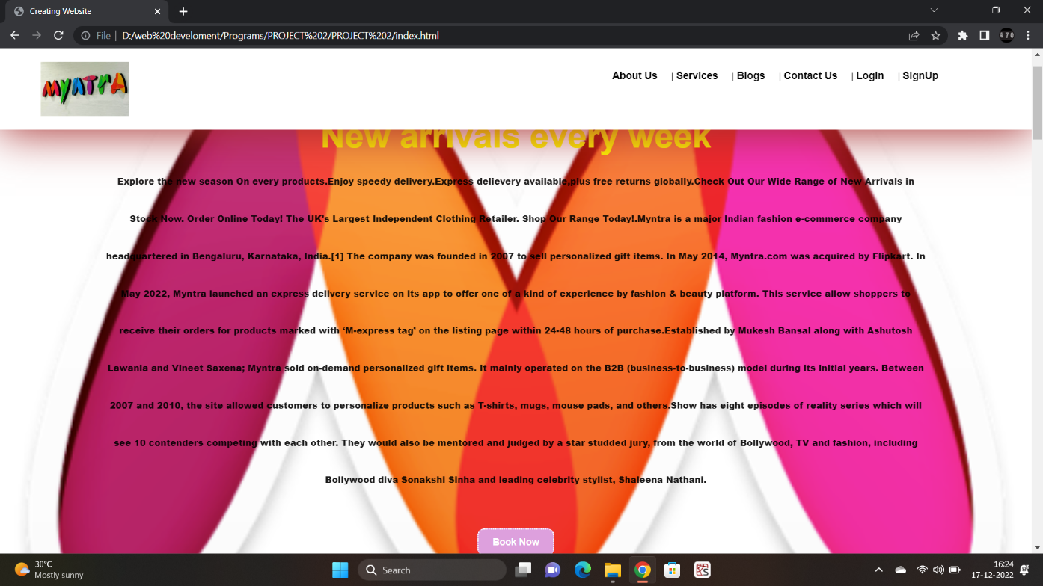

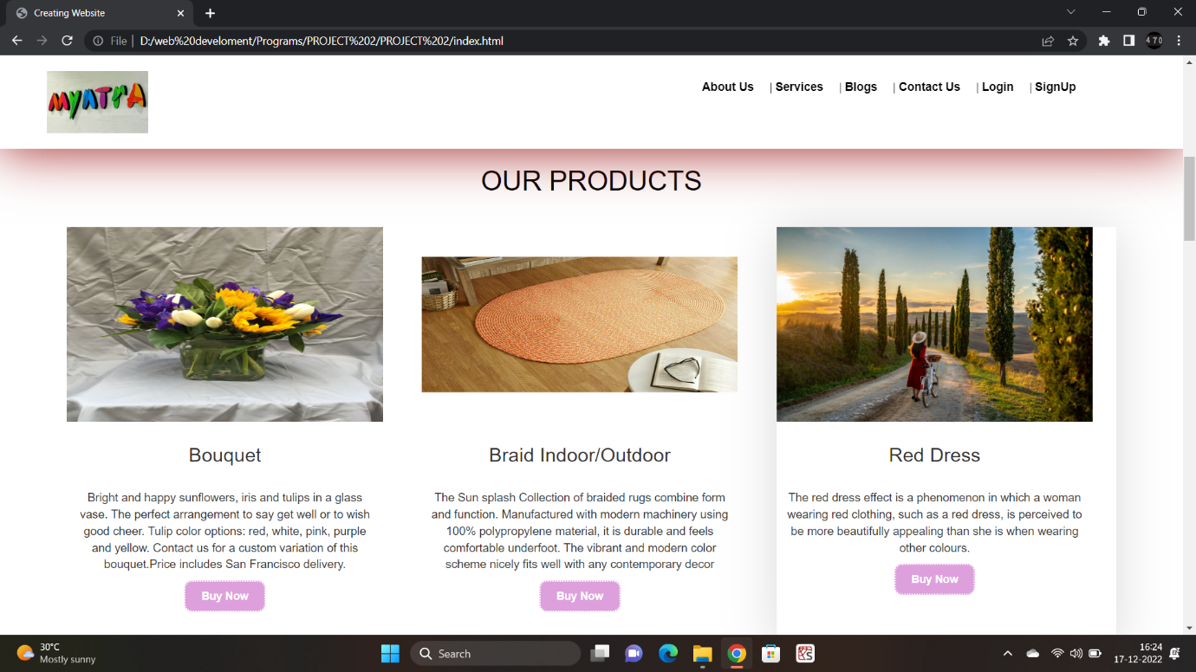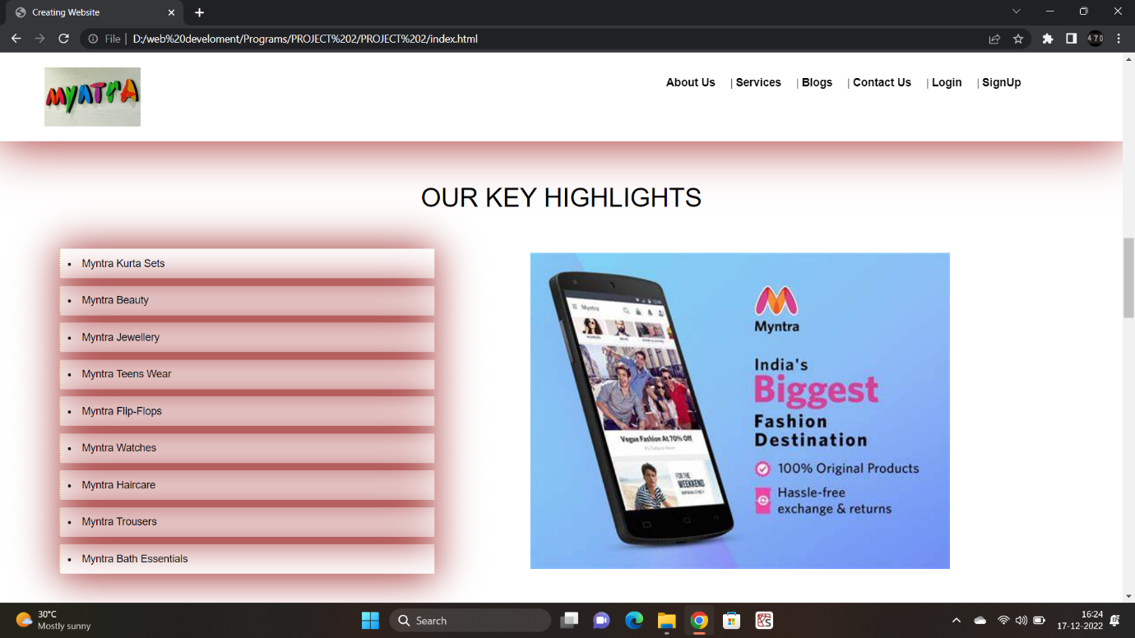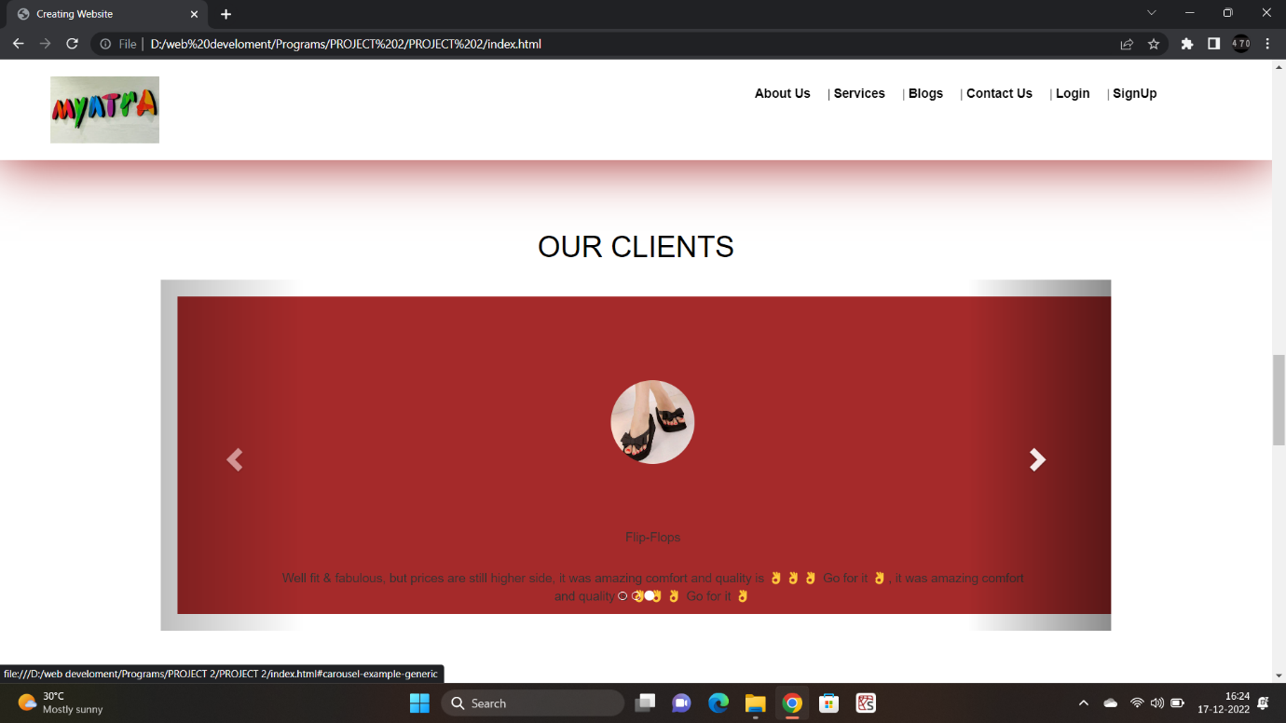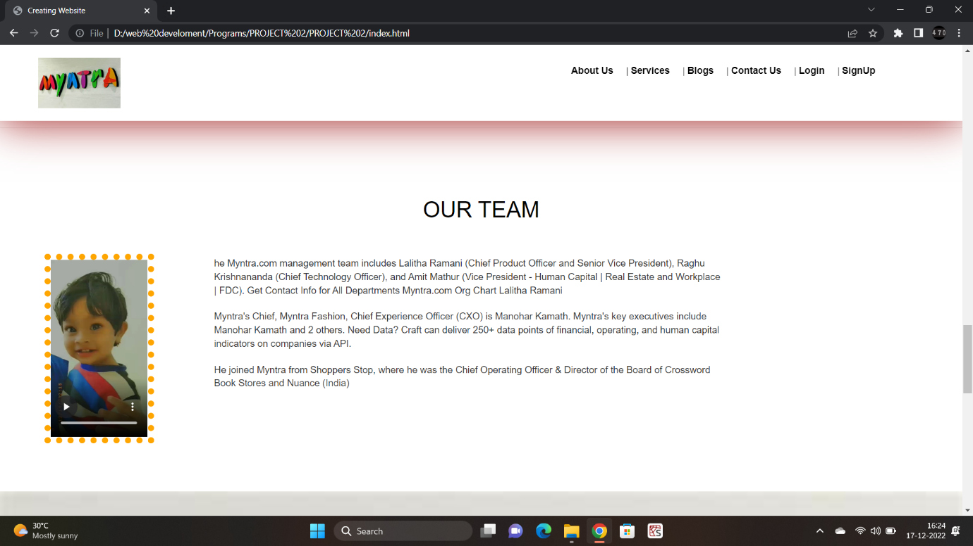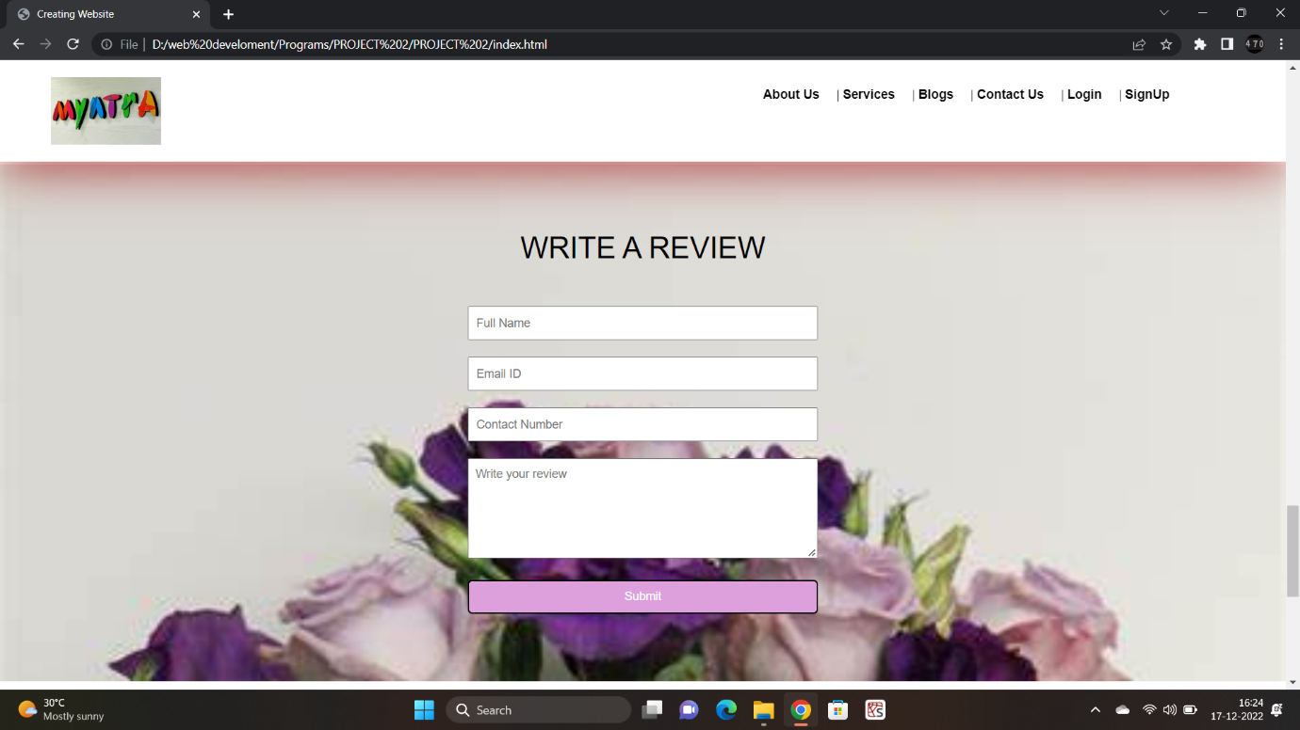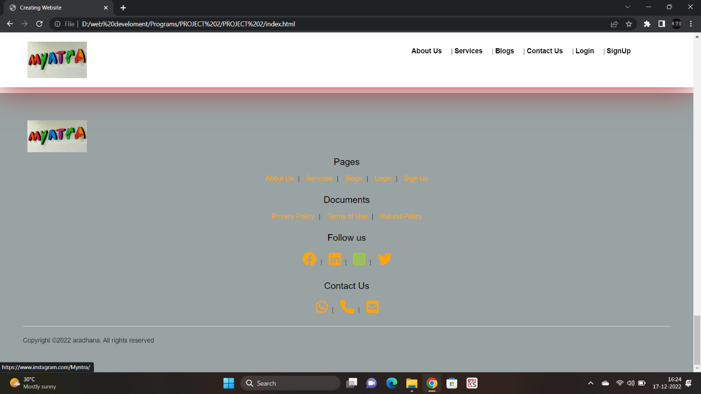

**8.2 Register Page (register.html)**

<!DOCTYPE html>

<html lang="en" >

<head>

  <meta charset="UTF-8">

  <title>Myntra | Sign Up</title>

  <link rel="stylesheet" href="./style.css">

</head>

<body>

<!-- partial:index.partial.html -->

<html lang="en">

<head>

  <!-- Latest compiled and minified CSS -->

<link rel="stylesheet" type="text/css" href="style.css">

<link rel="stylesheet" href="https://maxcdn.bootstrapcdn.com/bootstrap/3.3.5/css/bootstrap.min.css">

<link rel="stylesheet" href="https://cdnjs.cloudflare.com/ajax/libs/font-awesome/6.1.1/css/all.min.css" integrity="sha512-KfkfwYDsLkIlwQp6LFnl8zNdLGxu9YAA1QvwINks4PhcElQSvqcyVLLD9aMhXd13uQjoXtEKNosOWaZqXgel0g==" crossorigin="anonymous" referrerpolicy="no-referrer" />

  </head>

<body>

  <nav class="nav nav_top">

    <div class="logo">

        <a href="index.html"><img src="pic2.jpg" width="200"></a>

    </div>

    <div class="nav_side">

      <a href="about.html">About Us</a>|

      <a href="service.html">Services</a>|

      <a href="blog.html">Blogs</a>|

      <a href="contact.html">Contact Us</a>|

      <a href="login.html">Login</a>|

      <a href="register.html">SignUp</a>

    </div>

  </nav>

<div id="form">

  <div class="container">

    <div class="col-lg-6 col-lg-offset-3 col-md-6 col-md-offset-3 col-md-8 col-md-offset-2">

      <div id="userform">

        <div class="tab-content">

          <div class="tab-pane fade active in" id="signup">

            <h2 class="text-uppercase text-center"> Sign Up for Free</h2>

            <form id="signup">

              <div class="row">

                <div class="col-xs-12 col-sm-6">

                  <div class="form-group">

                    <label>First Name<span class="req">*</span> </label>

                    <input type="text" class="form-control" id="first_name" required data-validation-required-message="Please enter your name." autocomplete="off">

                    <p class="help-block text-danger"></p>

                  </div>

                </div>

                <div class="col-xs-12 col-sm-6">

                  <div class="form-group">

                    <label> Last Name<span class="req">*</span> </label>

                    <input type="text" class="form-control" id="last_name" required data-validation-required-message="Please enter your name." autocomplete="off">

                    <p class="help-block text-danger"></p>

                  </div>

                </div>

              </div>

              <div class="form-group">

                <label> Your Email<span class="req">*</span> </label>

                <input type="email" class="form-control" id="email" required data-validation-required-message="Please enter your email address." autocomplete="off">

                <p class="help-block text-danger"></p>

              </div>

              <div class="form-group">

                <label> Your Phone<span class="req">*</span> </label>

                <input type="tel" class="form-control" id="phone" required data-validation-required-message="Please enter your phone number." autocomplete="off">

                <p class="help-block text-danger"></p>

              </div>

              <div class="form-group">

                <label> Password<span class="req">*</span> </label>

                <input type="password" class="form-control" id="password" required data-validation-required-message="Please enter your password" autocomplete="off">

                <p class="help-block text-danger"></p>

              </div>

              <div class="mrgn-30-top">

                <button type="submit" class="btn btn-larger btn-block"/>

                Sign up

                </button>

              </div>

            </form>

          </div>

        </div>

      </div>

    </div>

  </div>

  <!-- /.container -->

</div>

<footer>

  <div class="logo">

      <a href="index.html"><img src="pic2.jpg" width="250px"></a>

  </div>

  <div class="pages">

      <h3>Pages</h3>

      <a href="about.html">About Us</a>|

      <a href="service.html">Services</a>|

      <a href="blog.html">Blogs</a>|

      <a href="login.html">Login</a>|

      <a href="register.html">SignUp</a>

  </div>

  <div class="doc">

      <h3>Documents</h3>

      <a href="about.html">Privacy Policy</a>|

      <a href="about.html">Terms of Use</a>|

      <a href="about.html">Refund Policy</a>

  </div>

  <div class="social">

      <h3>Follow Us</h3>

      <a href="https://www.facebook.com/myntra"  target="_blank"><i class="fa-brands fa-facebook"></i></a>|

    <a href="https://www.linkedin.com/company/myntra/" target="_blank"><i class="fa-brands fa-linkedin"></i></a>|

    <a href="https://www.instagram.com/Myntra/" target="_blank"><i class="fa-brands fa-instagram-square"></i></a>|

    <a href="https://twitter.com/myntra"  target="_blank"><i class="fa-brands fa-twitter"></i></a>

  </div>

  <div class="contact">

      <h3>Contact Us</h3>

      <a href="tel: +919912120506"><i class="fa-solid fa-phone"></i></a>|

      <a href="https://api.WhatsApp.com/send?phone=+919912120506"><i class="fa-brands fa-whatsapp"></i></a>|

      <a href="mailto: heyreema@gmail.com"><i class="fa-solid fa-square-envelope"></i></a>

  </div>

  <hr>

  <p>Copyright &copy; 2021 Myntra. All rights reserved</p>

</footer>

<script src="//code.jquery.com/jquery-1.11.3.min.js"></script>

<!-- Latest compiled and minified JavaScript -->

<script src="https://maxcdn.bootstrapcdn.com/bootstrap/3.3.5/js/bootstrap.min.js"></script>

</body>

</body>

</html>

**Output:**

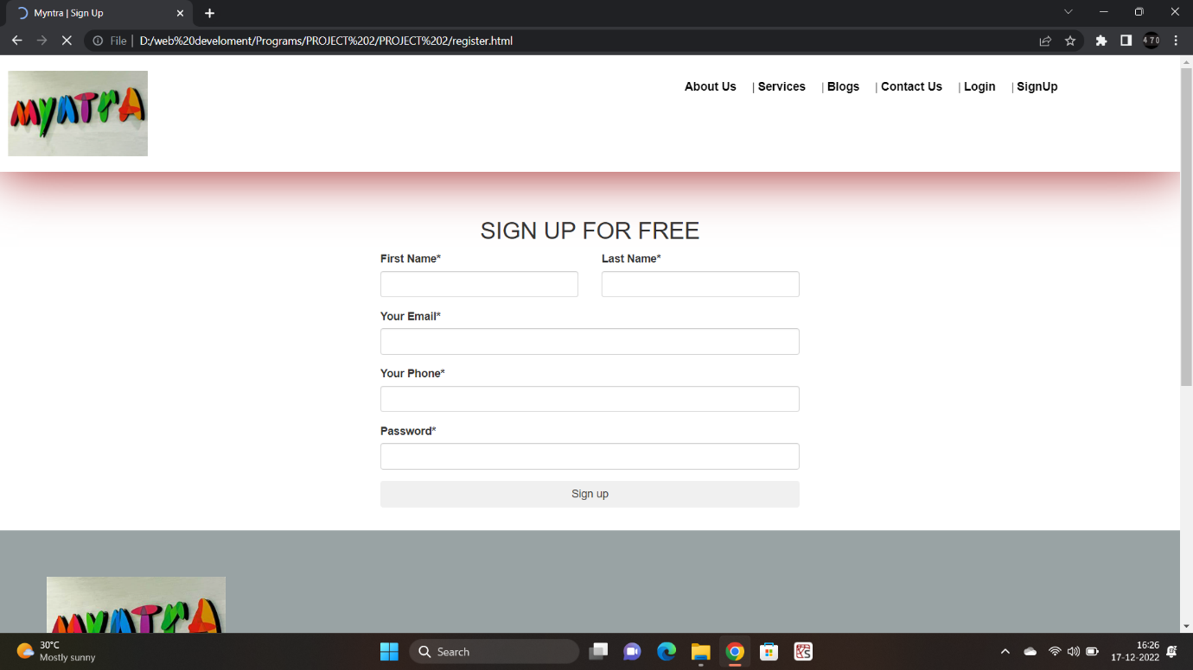

**8.3 Login Page (login.html)**

<!DOCTYPE html>

<html lang="en" >

<head>

  <meta charset="UTF-8">

  <title>Myntra | Log in</title>

  <link rel="stylesheet" href="./style.css">

  <link rel="stylesheet" href="https://cdnjs.cloudflare.com/ajax/libs/font-awesome/6.1.1/css/all.min.css" integrity="sha512-KfkfwYDsLkIlwQp6LFnl8zNdLGxu9YAA1QvwINks4PhcElQSvqcyVLLD9aMhXd13uQjoXtEKNosOWaZqXgel0g==" crossorigin="anonymous" referrerpolicy="no-referrer" />

</head>

<body>

<!-- partial:index.partial.html -->

<html lang="en">

<head>

  <!-- Latest compiled and minified CSS -->

<link rel="stylesheet" href="https://maxcdn.bootstrapcdn.com/bootstrap/3.3.5/css/bootstrap.min.css">

  </head>

<body>

    <nav class="nav nav_top">

        <div class="logo">

            <a href="index.html"><img src="pic2.jpg" width="200"></a>

        </div>

        <div class="nav_side">

          <a href="about.html">About Us</a>|

          <a href="service.html">Services</a>|

          <a href="blog.html">Blogs</a>|

          <a href="contact.html">Contact Us</a>|

          <a href="login.html">Login</a>|

          <a href="register.html">SignUp</a>

        </div>

    </nav>

<div id="form">

  <div class="container">

    <div class="col-lg-6 col-lg-offset-3 col-md-6 col-md-offset-3 col-md-8 col-md-offset-2">

      <div id="userform">

        <div class="tab-content">

          <div class="tab-pane fade active in" id="signup">

            <h2 class="text-uppercase text-center">Already Have a Account </h2>

            <div class="tab-pane fade in" id="login">

                <h2 class="text-uppercase text-center"> Log in</h2>

                <form id="login">

                  <div class="form-group">

                    <label> Your Email<span class="req">*</span> </label>

                    <input type="email" class="form-control" id="email" required data-validation-required-message="Please enter your email address." autocomplete="off">

                    <p class="help-block text-danger"></p>

                  </div>

                  <div class="form-group">

                    <label> Password<span class="req">*</span> </label>

                    <input type="password" class="form-control" id="password" required data-validation-required-message="Please enter your password" autocomplete="off">

                    <p class="help-block text-danger"></p>

                  </div>

                  <div class="mrgn-30-top">

                    <button type="submit" class="btn btn-larger btn-block"/>

                    Log in

                    </button>

                  </div>

                </form>

              </div>

          </div>

        </div>

      </div>

    </div>

  </div>

  <!-- /.container -->

</div>

<footer>

    <div class="logo">

        <a href="index.html"><img src="pic2.jpg" width="250px"></a>

    </div>

    <div class="pages">

        <h3>Pages</h3>

        <a href="about.html">About Us</a>|

        <a href="service.html">Services</a>|

        <a href="blog.html">Blogs</a>|

        <a href="login.html">Login</a>|

        <a href="register.html">SignUp</a>

    </div>

    <div class="doc">

        <h3>Documents</h3>

        <a href="about.html">Privacy Policy</a>|

        <a href="about.html">Terms of Use</a>|

        <a href="about.html">Refund Policy</a>

    </div>

    <div class="social">

        <h3>Follow Us</h3>

        <a href="https://www.facebook.com/myntra"  target="_blank"><i class="fa-brands fa-facebook"></i></a>|

        <a href="https://www.linkedin.com/company/myntra/" target="_blank"><i class="fa-brands fa-linkedin"></i></a>|

        <a href="https://www.instagram.com/Myntra/" target="_blank"><i class="fa-brands fa-instagram-square"></i></a>|

        <a href="https://twitter.com/myntra"  target="_blank"><i class="fa-brands fa-twitter"></i></a>

    </div>

    <div class="contact">

        <h3>Contact Us</h3>

        <a href="tel: +919912120506"><i class="fa-solid fa-phone"></i></a>|

        <a href="https://api.WhatsApp.com/send?phone=+919912120506"><i class="fa-brands fa-whatsapp"></i></a>|

        <a href="mailto: heyreema@gmail.com"><i class="fa-solid fa-square-envelope"></i></a>

    </div>

    <hr>

    <p>Copyright &copy; 2021 Myntra. All rights reserved</p>

</footer>

<script src="//code.jquery.com/jquery-1.11.3.min.js"></script>

<!-- Latest compiled and minified JavaScript -->

<script src="https://maxcdn.bootstrapcdn.com/bootstrap/3.3.5/js/bootstrap.min.js"></script>

</body>

</body>

</html>

**Output:**

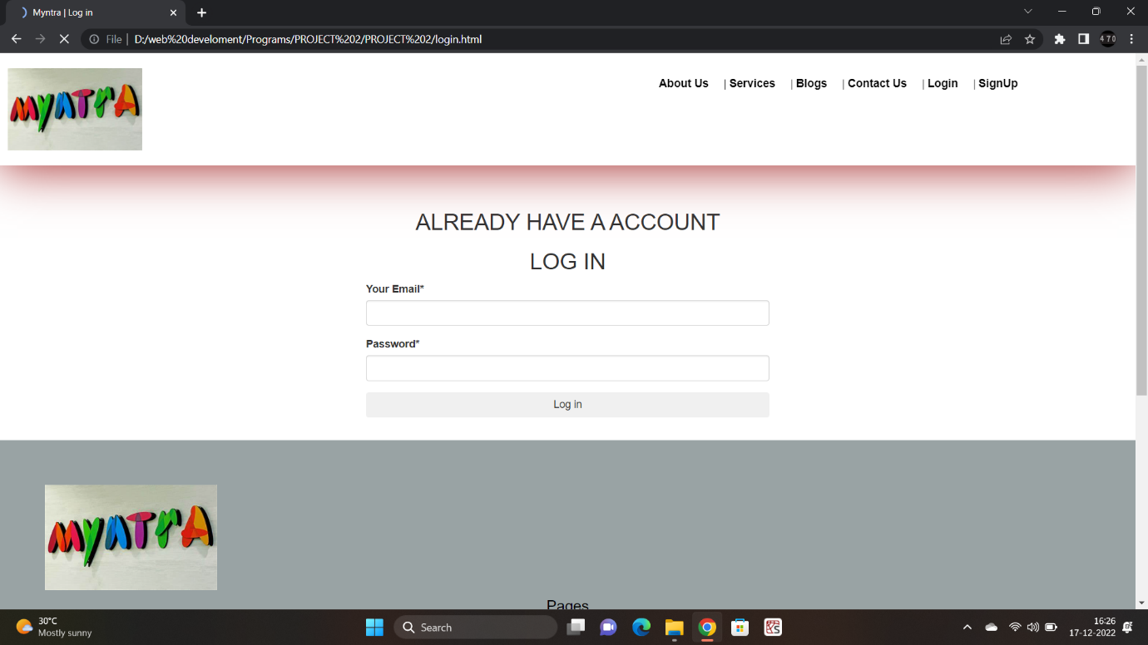

**8.4 About Us Page (about.html)**

<!DOCTYPE html>

<html>

<head>

    <title>About Us</title>

    <link rel="stylesheet" type="text/css" href="style.css">

    <link rel="stylesheet" type="text/css" href="https://cdnjs.cloudflare.com/ajax/libs/font-awesome/6.1.1/css/all.min.css">

</head>

<body>

        <nav class="nav nav_top">

        <div class="logo">

            <a href="index.html"><img src="pic2.jpg" width="150"></a>

        </div>

        <div class="nav_side">

            <a href="about.html">About Us</a>|

            <a href="service.html">Services</a>|

            <a href="blog.html">Blogs</a>|

            <a href="contact.html">Contact Us</a>|

            <a href="login.html">Login</a>|

            <a href="register.html">SignUp</a>

        </div>

    </nav>

<div class="about_us">

    <h2>About Us</h2>

    <div class="about_content">

        <p>Leading the  eCommerce revolution

We use technology to democratize fashion & lifestyle and help people look good.A Decade of Awesomeness. This is the Corporate blog of fashion & lifestyle company, Myntra. This features stories and news on the latest launches & developments... Home AboutInclusionCareersCultureBlogTech. This is the Corporate blog of fashion & lifestyle company, Myntra. This features stories and news on the latest launches & developments... Home AboutInclusionCareersCultureBlogTech. This is the Corporate blog of fashion & lifestyle company, Myntra. This features stories and news on the latest launches & developments... Home AboutInclusionCareersCultureBlogTech. This is the Corporate blog of fashion & lifestyle company, Myntra. This features stories and news on the latest launches & developments... Home AboutInclusionCareersCultureBlogTech. This is the Corporate blog of fashion & lifestyle company, Myntra. This features stories and news on the latest launches & developments... Home AboutInclusionCareersCultureBlogTech. This is the Corporate blog of fashion & lifestyle company, Myntra. This features stories and news on the latest launches & developments... Home AboutInclusionCareersCultureBlogTech. This is the Corporate blog of fashion & lifestyle company, Myntra. This features stories and news on the latest launches & developments... Home AboutInclusionCareersCultureBlogTech. This is the Corporate blog of fashion & lifestyle company, Myntra. This features stories and news on the latest launches & developments... Home AboutInclusionCareersCultureBlogTech. This is the Corporate blog of fashion & lifestyle company, Myntra. This features stories and news on the latest launches & developments... Home AboutInclusionCareersCultureBlogTech. This is the Corporate blog of fashion & lifestyle company, Myntra. This features stories and news on the latest launches & developments... Home AboutInclusionCareersCultureBlogTech. This is the Corporate blog of fashion & lifestyle company, Myntra. This features stories and news on the latest launches & developments... Home AboutInclusionCareersCultureBlogTech. This is the Corporate blog of fashion & lifestyle company, Myntra. This features stories and news on the latest launches & developments... Home AboutInclusionCareersCultureBlogTechThis is the Corporate blog of fashion & lifestyle company, Myntra. This features stories and news on the latest launches & developments... Home AboutInclusionCareersCultureBlogTechThis is the Corporate blog of fashion & lifestyle company, Myntra. This features stories and news on the latest launches & developments... Home AboutInclusionCareersCultureBlogTechThis is the Corporate blog of fashion & lifestyle company, Myntra. This features stories and news on the latest launches & developments... Home AboutInclusionCareersCultureBlogTech. </p>

    </div>

<hr>

    <h2>Our Mission</h2>

    <p>Tech Fashion All things Colourful. Established by Mukesh Bansal along with Ashutosh Lawania and Vineet Saxena; Myntra sold on-demand personalized gift items. It mainly operated on the B2B (business-to-business) model during its initial years. Between 2007 and 2010, the site allowed customers to personalize products such as T-shirts, mugs, mouse pads, and others.[11]

In 2011, Myntra began selling fashion and lifestyle products and moved away from personalisation. By 2012 Myntra offered products from 350 Indian and International brands. The website launched the brands Fastrack Watches and Being Human.[12]

In 2014, Myntra was acquired by Flipkart in a deal valued at ₹2,000 crore (US$250 million). The purchase was influenced by two large common shareholders Tiger Global and Accel Partners.[9] Myntra functions and operates independently.[13] Myntra continues to operate as a standalone brand under Flipkart ownership, focusing primarily on "fashion-conscious" consumers.[14]

In 2014, Myntra's portfolio included about 1,50,000 products of over 1000 brands, with a distribution area of around 9000 pincodes in India.[15] In 2015, Ananth Narayanan became the chief executive officer of Myntra.[16]

On 10 May 2015, Myntra announced that it would shut down its website, and serve customers exclusively through its mobile app beginning 15 May. The service had already discontinued its mobile website in favour of the app.[17] Myntra justified its decision by stating that 95% of traffic on its website came via mobile devices, and that 70% of its purchases were performed on smartphones. The move received mixed reception, and resulted in a 10% decline in sales.[18][19] In February 2016, acknowledging the failure of the "app-only" model, Myntra announced that it would revive its website.[20]

In September 2017, Myntra negotiated the rights to manage Esprit Holdings's 15 offline stores in India.[21][22] Myntra reported a net loss of ₹151.20 crore in the financial year 2017–2018.[23]

In January 2021, Myntra changed its logo, after a police complaint was registered that the logo resembles a naked woman. The complaint was filed by a woman named Naaz Patel, who runs an NGO called Avesta Foundation.[24]

Acquisitions an</p>

</div>

<div class="feed">

    <h2>Write a review</h2>

    <div class="feed_form">

        <form name="submit-to-google-sheet" method="post">

            <input type="text" name="Name" placeholder="Full Name" required><br>

            <input type="email" name="Email" placeholder="Email ID" required><br>

            <input type="number" name="Number" placeholder="Contact Number" required><br>

            <textarea rows="5" cols="7" name="Review" placeholder="Write your review"></textarea><br>

            <button type="Submit">Submit</button>

        </form>

    </div>

</div>

<hr>

<footer>

    <div class="logo">

        <a href="index.html"><img src="pic2.jpg" width="150" height="90px"></a>

    </div>

    <br>

    <br>

    <br>

    <div class="pages">

        <h3>Pages</h3>

        <a href="about.html">About Us</a>|

        <a href="service.html">Services</a>|

        <a href="blog.html">Blogs</a>|

        <a href="login.html">Login</a>|

        <a href="register.html">Sign Up</a>

    </div>

    <div class="doc">

        <h3>Documents</h3>

        <a href="about.html">Privacy Policy</a>|

        <a href="about.html">Terms of Use</a>|

        <a href="about.html">Refund Policy</a>

    </div>

    <div class="social">

        <h3>Follow us</h3>

        <a href="https://www.facebook.com/myntra"  target="_blank"><i class="fa-brands fa-facebook"></i></a>|

        <a href="https://www.linkedin.com/company/myntra/" target="_blank"><i class="fa-brands fa-linkedin"></i></a>|

        <a href="https://www.instagram.com/Myntra/" target="_blank"><i class="fa-brands fa-instagram-square"></i></a>|

        <a href="https://twitter.com/myntra"  target="_blank"><i class="fa-brands fa-twitter"></i></a>

    </div>

    <div class="contact">

        <h3>Contact Us</h3>

        <a href="tel: +919032420982"><i class="fa-brands fa-whatsapp"></i></a>|

        <a href="mailto: heyreema@gmail.com"><i class="fa-solid fa-phone"></i></a>|

        <a href="mailto: abc@gmail.com"><i class="fa-solid fa-square-envelope"></i></a>

    </div>

    <hr>

    <p>Copyright &copy;2022 Myntra. All rights reserved</p>

</footer>

 <!-- jQuery (necessary for Bootstrap's JavaScript plugins) -->

    <script src="https://code.jquery.com/jquery-1.12.4.min.js" integrity="sha384-nvAa0+6Qg9clwYCGGPpDQLVpLNn0fRaROjHqs13t4Ggj3Ez50XnGQqc/r8MhnRDZ" crossorigin="anonymous"></script>

<!-- Latest compiled and minified JavaScript -->

<script src="https://cdn.jsdelivr.net/npm/bootstrap@3.4.1/dist/js/bootstrap.min.js" integrity="sha384-aJ21OjlMXNL5UyIl/XNwTMqvzeRMZH2w8c5cRVpzpU8Y5bApTppSuUkhZXN0VxHd" crossorigin="anonymous"></script>

<script>

  const scriptURL = 'https://script.google.com/macros/s/AKfycbxnTN1JSgXNzfsnqRLjVnhPYLf-gB2kZVbwcjXWbcG9yU7JwLdbuYLD8i-QMshUs_Ft/exec'

  const form = document.forms['submit-to-google-sheet']

  form.addEventListener('submit', e => {

    e.preventDefault()

    fetch(scriptURL, { method: 'POST', body: new FormData(form)})

      .then(response => alert('Success!', response))

      .catch(error => console.error('Error!', error.message))

  })

</script>

</body>

</html>

**Output:**

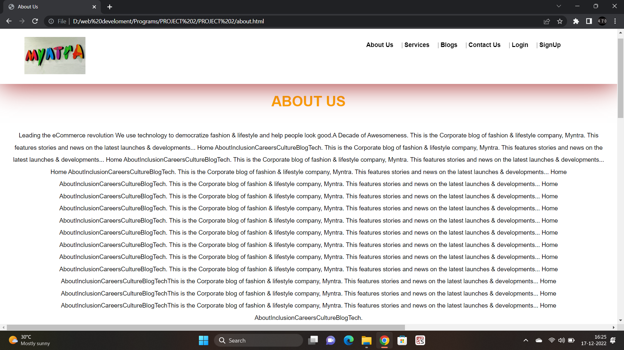

**8.5 Blog Page (blog.html)**

<!DOCTYPE html>

<html>

<head>

    <title>Blog</title>

    <link rel="stylesheet" type="text/css" href="style.css">

    <link rel="stylesheet" type="text/css" href="https://cdnjs.cloudflare.com/ajax/libs/font-awesome/6.1.1/css/all.min.css">

</head>

<body>

        <nav class="nav nav_top">

        <div class="logo">

            <a href="index.html"><img src="pic2.jpg" width="150"></a>

        </div>

        <div class="nav_side">

            <a href="about.html">About Us</a>|

            <a href="service.html">Services</a>|

            <a href="blog.html">Blogs</a>|

            <a href="contact.html">Contact Us</a>|

            <a href="login.html">Login</a>|

            <a href="register.html">SignUp</a>

        </div>

    </nav>

<div class="blog" style="padding-top: 125px;">

    <h2>FRESHLY MYNTED

    ...only for you!</h2>

    <div class="blog_content">

        <p>Recreate Your Favorite Stranger Things Looks Using these Products from Myntra</p>

    </div>

<hr>

    <h2>Business</h2>

    <p>For Myntraites and our Partners, the End of Reason Sale (EORS 16) is nothing short of a festival, it’s a grand event that keeps us on our toes and gives us and our partner ecosystem the opportunity to grow every year. To celebrate the success of the last EORS and give away awards to our brand partners who performed phenomenally during the mega carnival event, we held a webinar recently.

The super-interactive and insightful webinar covered the new and upcoming initiatives for brand partners and featured interviews with some of the winners of the last EORS as well. This is the Corporate blog of fashion & lifestyle company, Myntra. This features stories and news on the latest launches & developments... Home AboutInclusionCareersCultureBlogTech. This is the Corporate blog of fashion & lifestyle company, Myntra. This features stories and news on the latest launches & developments... Home AboutInclusionCareersCultureBlogTech. This is the Corporate blog of fashion & lifestyle company, Myntra. This features stories and news on the latest launches & developments... Home AboutInclusionCareersCultureBlogTech. This is the Corporate blog of fashion & lifestyle company, Myntra. This features stories and news on the latest launches & developments... Home AboutInclusionCareersCultureBlogTech.</p>

</div>

<div class="feed">

    <h2>Write a review</h2>

    <div class="feed_form">

        <form name="submit-to-google-sheet" method="post">

            <input type="text" name="Name" placeholder="Full Name" required><br>

            <input type="email" name="Email" placeholder="Email ID" required><br>

            <input type="number" name="Number" placeholder="Contact Number" required><br>

            <textarea rows="5" cols="7" name="Review" placeholder="Write your review"></textarea><br>

            <button type="Submit">Submit</button>

        </form>

    </div>

</div>

<hr>

<footer>

    <div class="logo">

        <a href="index.html"><img src="pic2.jpg" width="150" height="90px"></a>

    </div>

    <br>

    <br>

    <br>

    <div class="pages">

        <h3>Pages</h3>

        <a href="about.html">About Us</a>|

        <a href="service.html">Services</a>|

        <a href="blog.html">Blogs</a>|

        <a href="login.html">Login</a>|

        <a href="register.html">Sign Up</a>

    </div>

    <div class="doc">

        <h3>Documents</h3>

        <a href="about.html">Privacy Policy</a>|

        <a href="about.html">Terms of Use</a>|

        <a href="about.html">Refund Policy</a>

    </div>

    <div class="social">

        <h3>Follow us</h3>

        <a href="https://www.facebook.com/myntra"  target="_blank"><i class="fa-brands fa-facebook"></i></a>|

        <a href="https://www.linkedin.com/company/myntra/" target="_blank"><i class="fa-brands fa-linkedin"></i></a>|

        <a href="https://www.instagram.com/Myntra/" target="_blank"><i class="fa-brands fa-instagram-square"></i></a>|

        <a href="https://twitter.com/myntra"  target="_blank"><i class="fa-brands fa-twitter"></i></a>

    </div>

    <div class="contact">

        <h3>Contact Us</h3>

        <a href="tel: +919032420982"><i class="fa-brands fa-whatsapp"></i></a>|

        <a href="mailto: heyreema@gmail.com"><i class="fa-solid fa-phone"></i></a>|

        <a href="mailto: abc@gmail.com"><i class="fa-solid fa-square-envelope"></i></a>

    </div>

    <hr>

    <p>Copyright &copy;2022 aradhana. All rights reserved</p>

</footer>

 <!-- jQuery (necessary for Bootstrap's JavaScript plugins) -->

    <script src="https://code.jquery.com/jquery-1.12.4.min.js" integrity="sha384-nvAa0+6Qg9clwYCGGPpDQLVpLNn0fRaROjHqs13t4Ggj3Ez50XnGQqc/r8MhnRDZ" crossorigin="anonymous"></script>

<!-- Latest compiled and minified JavaScript -->

<script src="https://cdn.jsdelivr.net/npm/bootstrap@3.4.1/dist/js/bootstrap.min.js" integrity="sha384-aJ21OjlMXNL5UyIl/XNwTMqvzeRMZH2w8c5cRVpzpU8Y5bApTppSuUkhZXN0VxHd" crossorigin="anonymous"></script>

<script>

*const* scriptURL = 'https://script.google.com/macros/s/AKfycbxnTN1JSgXNzfsnqRLjVnhPYLf-gB2kZVbwcjXWbcG9yU7JwLdbuYLD8i-QMshUs_Ft/exec'

*const* form = document.forms['submit-to-google-sheet']

  form.addEventListener('submit', *e* *=>* {

*e*.preventDefault()

    fetch(scriptURL, { method: 'POST', body: new *FormData*(form)})

      .then(*response* *=>* alert('Success!', *response*))

      .catch(*error* *=>* console.error('Error!', *error*.message))

  })

</script>

</body>

</html>

**Output:**

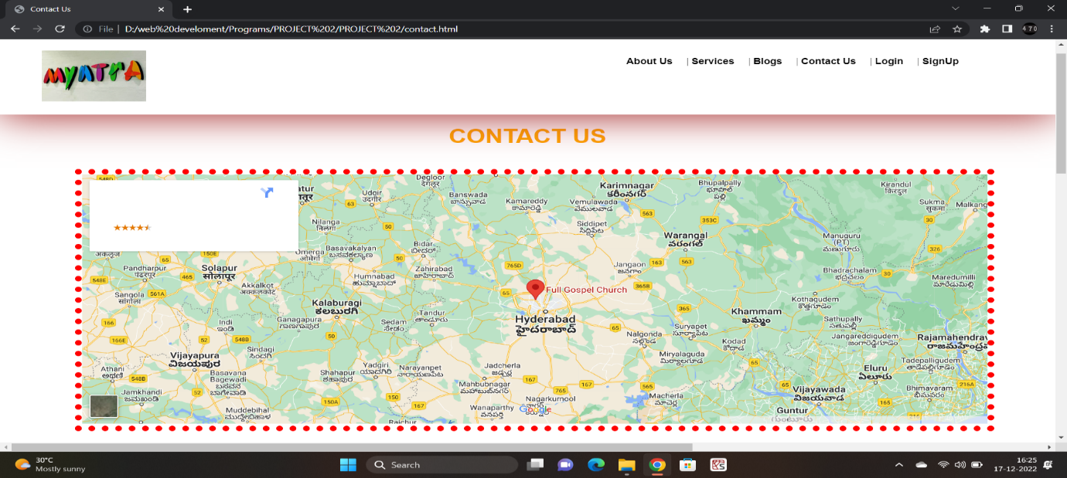

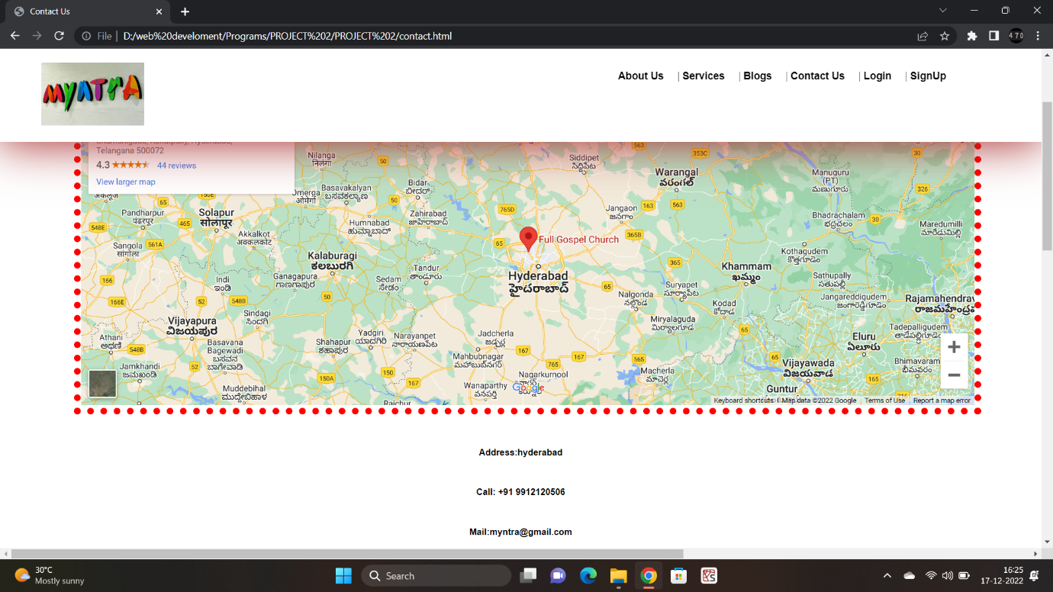

**8.6 Contact Page (contact.html)**

<!DOCTYPE html>

<html>

<head>

    <meta charset="utf-8">

    <meta name="viewport" content="width=device-width, initial-scale=1">

    <title>Contact Us</title>

    <link rel="stylesheet" type="text/css" href="style.css">

    <link rel="stylesheet" type="text/css" href="https://cdnjs.cloudflare.com/ajax/libs/font-awesome/6.1.1/css/all.min.css">

</head>

<body>

    <nav class="nav nav_top">

        <div class="logo">

            <a href="index.html"><img src="pic2.jpg" width="150"></a>

        </div>

        <div class="nav_side">

            <a href="about.html">About Us</a>|

            <a href="service.html">Services</a>|

            <a href="blog.html">Blogs</a>|

            <a href="contact.html">Contact Us</a>|

            <a href="login.html">Login</a>|

            <a href="register.html">SignUp</a>

        </div>

    </nav>

    <div class="contact_container">

        <h2 style="padding-top: 50px;">Contact Us</h2>

        <div class="g_map">

            <iframe src="https://www.google.com/maps/embed?pb=!1m18!1m12!1m3!1d974096.8932077799!2d77.28474663124999!3d17.504363100000017!2m3!1f0!2f0!3f0!3m2!1i1024!2i768!4f13.1!3m3!1m2!1s0x3bcb91e873019b53%3A0x1b3b7a08a3db3d6c!2sFull%20Gospel%20Church!5e0!3m2!1sen!2sin!4v1655817405843!5m2!1sen!2sin" width="100%" height="450" style="border:0;" allowfullscreen="" loading="lazy" referrerpolicy="no-referrer-when-downgrade"></iframe>

        </div>

        <div class="contact_content">

            <p><b>Address:hyderabad</b></p>

            <p><b>Call: +91 9912120506</b></p>

            <p><b>Mail:myntra@gmail.com</b></p>

        </div>

    </div>

<div class="feed">

    <h2>Write a review</h2>

    <div class="feed_form">

        <form name="submit-to-google-sheet" method="post">

            <input type="text" name="Name" placeholder="Full Name" required><br>

            <input type="email" name="Email" placeholder="Email ID" required><br>

            <input type="number" name="Number" placeholder="Contact Number" required><br>

            <textarea rows="5" cols="7" name="Review" placeholder="Write your review"></textarea><br>

            <button type="Submit">Submit</button>

        </form>

    </div>

</div>

<hr>

<footer>

    <div class="logo">

        <a href="index.html"><img src="pic2.jpg" width="150" height="90px"></a>

    </div>

    <br>

    <br>

    <br>

    <div class="pages">

        <h3>Pages</h3>

        <a href="about.html">About Us</a>|

        <a href="service.html">Services</a>|

        <a href="blog.html">Blogs</a>|

        <a href="login.html">Login</a>|

        <a href="register.html">Sign Up</a>

    </div>

    <div class="doc">

        <h3>Documents</h3>

        <a href="about.html">Privacy Policy</a>|

        <a href="about.html">Terms of Use</a>|

        <a href="about.html">Refund Policy</a>

    </div>

    <div class="social">

        <h3>Follow us</h3>

        <a href="https://www.facebook.com/myntra"  target="_blank"><i class="fa-brands fa-facebook"></i></a>|

        <a href="https://www.linkedin.com/company/myntra/" target="_blank"><i class="fa-brands fa-linkedin"></i></a>|

        <a href="https://www.instagram.com/Myntra/" target="_blank"><i class="fa-brands fa-instagram-square"></i></a>|

        <a href="https://twitter.com/myntra"  target="_blank"><i class="fa-brands fa-twitter"></i></a>

    </div>

    <div class="contact">

        <h3>Contact Us</h3>

        <a href="tel: +919032420982"><i class="fa-brands fa-whatsapp"></i></a>|

        <a href="mailto: heyreema@gmail.com"><i class="fa-solid fa-phone"></i></a>|

        <a href="mailto: abc@gmail.com"><i class="fa-solid fa-square-envelope"></i></a>

    </div>

    <hr>

    <p>Copyright &copy;2022 Myntra. All rights reserved</p>

</footer>

 <!-- jQuery (necessary for Bootstrap's JavaScript plugins) -->

    <script src="https://code.jquery.com/jquery-1.12.4.min.js" integrity="sha384-nvAa0+6Qg9clwYCGGPpDQLVpLNn0fRaROjHqs13t4Ggj3Ez50XnGQqc/r8MhnRDZ" crossorigin="anonymous"></script>

<!-- Latest compiled and minified JavaScript -->

<script src="https://cdn.jsdelivr.net/npm/bootstrap@3.4.1/dist/js/bootstrap.min.js" integrity="sha384-aJ21OjlMXNL5UyIl/XNwTMqvzeRMZH2w8c5cRVpzpU8Y5bApTppSuUkhZXN0VxHd" crossorigin="anonymous"></script>

<script>

*const* scriptURL = 'https://script.google.com/macros/s/AKfycbxnTN1JSgXNzfsnqRLjVnhPYLf-gB2kZVbwcjXWbcG9yU7JwLdbuYLD8i-QMshUs_Ft/exec'

*const* form = document.forms['submit-to-google-sheet']

  form.addEventListener('submit', *e* *=>* {

*e*.preventDefault()

    fetch(scriptURL, { method: 'POST', body: new *FormData*(form)})

      .then(*response* *=>* alert('Success!', *response*))

      .catch(*error* *=>* console.error('Error!', *error*.message))

  })

</script>

</body>

</html>

</body>

</html>

**Output:**

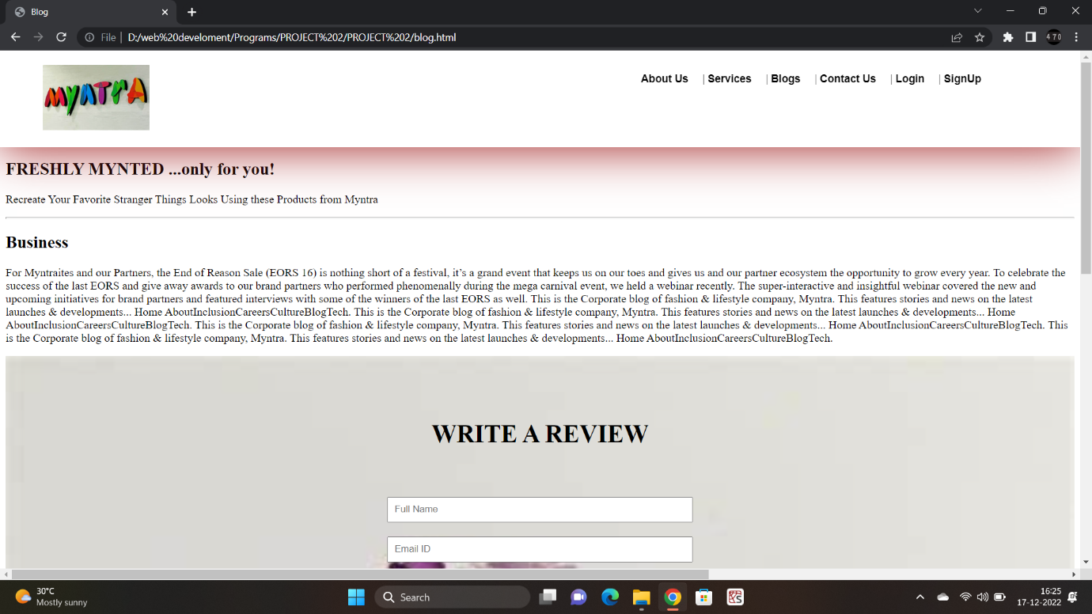

**8.7 Services Page (service.html)**

<!DOCTYPE html>

<html lang="en">

<head>

    <meta charset="UTF-8">

    <meta http-equiv="X-UA-Compatible" content="IE=edge">

    <meta name="viewport" content="width=device-width, initial-scale=1.0">

    <title>Myntra | Services</title>

    <link rel="stylesheet" type="text/css" href="style.css">

    <link rel="stylesheet" href="https://cdnjs.cloudflare.com/ajax/libs/font-awesome/6.1.1/css/all.min.css" integrity="sha512-KfkfwYDsLkIlwQp6LFnl8zNdLGxu9YAA1QvwINks4PhcElQSvqcyVLLD9aMhXd13uQjoXtEKNosOWaZqXgel0g==" crossorigin="anonymous" referrerpolicy="no-referrer" />

</head>

<body>

    <nav class="nav nav_top">

        <div class="logo">

            <a href="index.html"><img src="pic2.jpg" width="200"></a>

        </div>

        <div class="nav_side">

            <a href="about.html">About Us</a>|

            <a href="service.html">Services</a>|

            <a href="blog.html">Blogs</a>|

            <a href="contact.html">Contact Us</a>|

            <a href="login.html">Login</a>|

            <a href="register.html">SignUp</a>

        </div>

    </nav>

    <div class="product" style="padding-top: 100px;">

        <h2>OUR PRODUCTS</h2>

        <div class="product_container" style="padding-bottom: 50px;">

            <div class="item">

                <div class="item_img">

                    <img src="p1.jpg">

                </div>

                <div class="item_content">

                    <h3>Tablets</h3>

                    <p>Apple tablets are available in our store. Starts at 20,000 rupees...</p>

                    <a href=" ">Buy Now</a>

                    <br>

                    <br>

                    <br>

                </div>

            </div>

            <div class="item">

                <div class="item_img">

                    <img src="p2.jpg">

                </div>

                <div class="item_content">

                    <h3>Phones</h3>

                    <p>Apple phones are available iin our store. Starts at 20,000 rupees...</p>

                    <a href=" ">Buy Now</a>

                    <br>

                    <br>

                    <br>

                </div>

            </div>

            <div class="item">

                <div class="item_img">

                    <img src="p3.jpg">

                </div>

                <div class="item_content">

                    <h3>Watches & Earphones</h3>

                    <p>Apple watches & earphones are available iin our store. Starts at 20,000 rupees...</p>

                    <a href=" ">Buy Now</a>

                    <br>

                    <br>

                    <br>

                </div>

            </div>

        </div>

        <div class="product_container">

            <div class="item">

                <div class="item_img">

                    <img src="p1.jpg">

                </div>

                <div class="item_content">

                    <h3>Tablets</h3>

                    <p>Apple tablets are available iin our store. Starts at 20,000 rupees...</p>

                    <a href=" ">Buy Now</a>

                    <br>

                    <br>

                    <br>

                </div>

            </div>

            <div class="item">

                <div class="item_img">

                    <img src="p2.jpg">

                </div>

                <div class="item_content">

                    <h3>Phones</h3>

                    <p>Apple phones are available iin our store. Starts at 20,000 rupees...</p>

                    <a href=" ">Buy Now</a>

                    <br>

                    <br>

                    <br>

                </div>

            </div>

            <div class="item">

                <div class="item_img">

                    <img src="p3.jpg">

                </div>

                <div class="item_content">

                    <h3>Watches & Earphones</h3>

                    <p>Apple watches & earphones are available iin our store. Starts at 20,000 rupees...</p>

                    <a href=" ">Buy Now</a>

                    <br>

                    <br>

                    <br>

                </div>

            </div>

        </div>

    </div>

    <div class="feed">

        <h2>Write a review</h2>

        <div class="feed_form">

            <form name="submit-to-google-sheet" method="post">

                <input type="text" name="Name" placeholder="Name"><br>

                <input type="email" name="Email ID" placeholder="Email ID"><br>

                <input type="number" name="Number" placeholder="Contact Number"><br>

                <textarea rows="5" cols="7" name="Feedback" placeholder="Write your review"></textarea><br>

                <button type="submit">Submit</button>

            </form>

        </div>

    </div>

    <footer>

        <div class="logo">

            <a href="index.html"><img src="pic2.jpg" width="250px"></a>

        </div>

        <div class="pages">

            <h3>Pages</h3>

            <a href="about.html">About Us</a>|

            <a href="service.html">Services</a>|

            <a href="blog.html">Blogs</a>|

            <a href="login.html">Login</a>|

            <a href="register.html">Sign Up</a>

        </div>

        <div class="doc">

            <h3>Documents</h3>

            <a href="about.html">Privacy Policy</a>|

            <a href="about.html">Terms of Use</a>|

            <a href="about.html">Refund Policy</a>

        </div>

        <div class="social">

            <h3>Follow Us</h3>

            <a href="https://www.facebook.com/myntra"  target="_blank"><i class="fa-brands fa-facebook"></i></a>|

        <a href="https://www.linkedin.com/company/myntra/" target="_blank"><i class="fa-brands fa-linkedin"></i></a>|

        <a href="https://www.instagram.com/Myntra/" target="_blank"><i class="fa-brands fa-instagram-square"></i></a>|

        <a href="https://twitter.com/myntra"  target="_blank"><i class="fa-brands fa-twitter"></i></a>

        </div>

        <div class="contact">

            <h3>Contact Us</h3>

            <a href="tel: +919912120506"><i class="fa-solid fa-phone"></i></a>|

            <a href="https://api.WhatsApp.com/send?phone=+919912120506"><i class="fa-brands fa-whatsapp"></i></a>|

            <a href="mailto: abc@gmail.com"><i class="fa-solid fa-square-envelope"></i></a>

        </div>

        <hr>

        <p>Copyright &copy; 2021 Myntra. All rights reserved</p>

    </footer>

    <script>

*const* scriptURL = 'https://script.google.com/macros/s/AKfycbz-qdFCW2W94oD91rKMSDL4r7-DtRhdXVvmYQNrdBq5XD3Pyo0xeRarmIFtHOT9xfTs/exec'

*const* form = document.forms['submit-to-google-sheet']

        form.addEventListener('submit', *e* *=>* {

*e*.preventDefault()

          fetch(scriptURL, { method: 'POST', body: new *FormData*(form)})

            .then(*response* *=>* alert('Success!', *response*))

            .catch(*error* *=>* console.error('Error!', *error*.message))

        })

      </script>

</body>

</html>

**Output:**

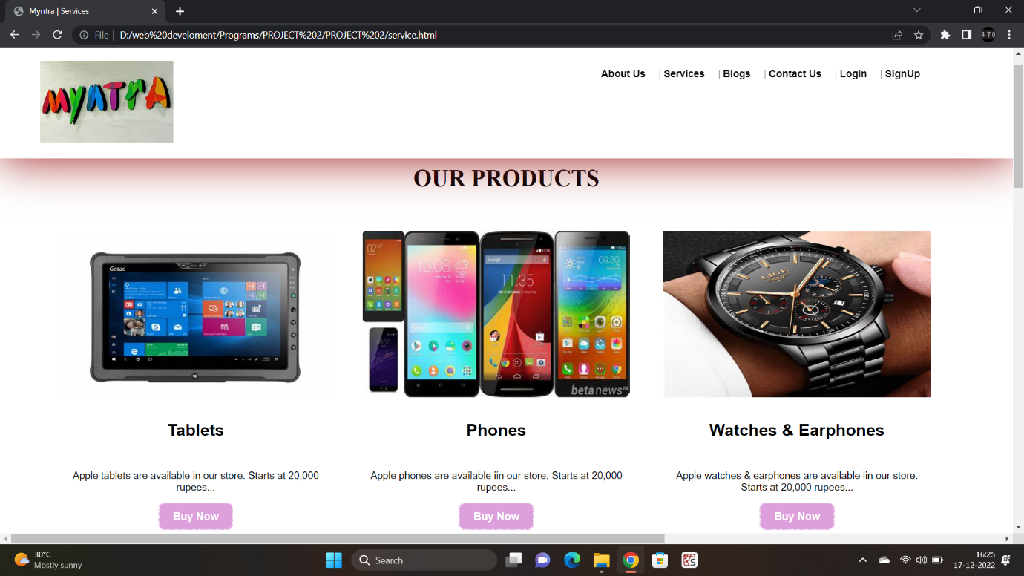

**8.8 Style CSS Page (style.css)**

.nav{

*background-color*: white;

*z-index*: 9;

*padding*: 10px;

*padding-left*:50px;

*padding-right*: 50px;

*display*: flex;

*box-shadow*: 0px 3px 65px 0px brown;

}

.nav_top{

*position*: fixed;

*top*: 0;

*right*: 0;

*left*: 0;

}

.logo{

*float*: left;

*width*: 60%;

}

.logo img{

*padding*: 10px;

}

.nav_side{

*float*: right;

*width*: 40%;

*margin-top*: 20px;

}

.nav_side a{

*text-decoration*: none;

*margin-right*: 20px;

*color*: black;

*font-weight*: bold;

*font-family*: cosmic,sans-serif;

*font-size*: 15px;

*justify-content*: center;

*align-items*: center;

*align-content*: center;

*text-align*: center;

}

.nav_side a:hover{

*color*: hotpink;

*text-decoration*: underline;

*transition*: all 1s ease;

}

.main{

*background-image*: url("pic1.jpg");

*background-position*: center;

*background-size*: cover;

*background-repeat*: no-repeat;

*background-attachment*: fixed;

*height*: 100%;

}

.main .main_content{

*margin-top*: 100px;

*padding-top*: 50px;

*margin-left*:10% ;

*margin-right*: 10%;

*text-align*: center;

}

.main .main_content h2{

*color*: yellow;

*font-size*: 50px;

*font-family*: cosmic,sans-serif;

*font-weight*: bolder;

*text-align*: center;

}

.main .main_content h2 span{

*font-size*: 13px;

*opacity*: 0.9;

*color*: black;

*font-weight*: bolder;

*text-align*: center;

*line-height*: 20px;

}

.main .main_content .btn{

*margin-top*: 50px;

*text-align*: center;

}

.main .main_content .btn a{

*text-decoration*: none;

*margin*:50px;

*padding*: 10px 20px;

*background-color*: plum;

*font-weight*: bold;

*font-family*: cosmic,sans-serif;

*border*: 2px dotted white;

*border-radius*: 10px;

*color*: white;

*text-align*: center;

*transition*: .5s;

}

.main .main_content .btn a:hover{

*background-color*: black;

*color*: orange;

*border*: none;

*border-bottom*: 4px solid orange;

*transition*: 1s;

}

.product{

*padding-bottom*: 50px;

}

.product h2{

*color*: black;

*font-size*: 35px;

*text-align*: center;

*padding*: 20px;

*padding-top*: 75px;

}

.product .product_container{

*display*:flex ;

*margin-left*: 5%;

*margin-right*: 5%;

}

.product .product_container .item{

*width*: 33.33%;

*padding-right*: 30px;

*margin*: 10px;

*height*: auto;

*padding-bottom*: 15px;

}

.product .product_container .item:hover{

*box-shadow*: 0px 3px 65px 0px rgba(0, 0, 0, .15);

}

.product .product_container .item .item_img{

*width*: 100%;

*height*: 250px;

*overflow*: hidden;

}

.product .product_container .item .item_img img{

*width*: 100%;

*height*: 250px;

}

.product .product_container .item .item_content{

*text-align*: center;

*overflow*: hidden;

}

.product .product_container .item .item_content h3{

*padding*: 10px;

*font-size*: 25px;

*font-family*: cosmic,sans-serif;

}

.product .product_container .item .item_content p{

*padding*: 10px;

*font-size*: 15px;

*font-family*: cosmic,sans-serif;

}

.product .product_container .item .item_content a{

*text-decoration*: none;

*margin*:50px;

*padding*: 10px 20px;

*background-color*: plum;

*font-weight*: bold;

*font-family*: cosmic,sans-serif;

*border*: 2px dotted white;

*border-radius*: 10px;

*color*: white;

*text-align*: center;

*transition*: .5s;

}

.product .product_container .item .item_content a:hover{

*background-color*: black;

*color*: orange;

*border*: none;

*border-bottom*: 4px solid orange;

*transition*: 1s;

}

.product .product_btn{

*text-align*: center;

*margin-top*: 50px;

}

.product .product_btn a{

*text-decoration*: none;

*margin*:50px;

*padding*: 10px 20px;

*background-color*: plum;

*font-weight*: bold;

*font-family*: cosmic,sans-serif;

*border*: 2px dotted white;

*border-radius*: 10px;

*color*: white;

*text-align*: center;

*transition*: .5s;

}

.product .product_btn a:hover{

*background-color*: black;

*color*: orange;

*border*: none;

*border-bottom*: 4px solid orange;

*transition*: 1s;

}

.keypoint{

*padding*: 50px;

}

.keypoint h2{

*color*: black;

*font-size*: 35px;

*text-align*: center;

*padding*: 10px;

}

.keypoint .key_container{

*display*: flex;

}

.keypoint .key_container .key_content{

*width*: 40%;

*padding*: 20px;

*float*: left;

}

.keypoint .key_container .key_content li{

*margin*: 10px;

*padding*: 10px;

*border-left*: 2px dotted orange;

*color*: black;

*text-align*: left;

*font-family*: cosmic,sans-serif;

*box-shadow*: 0px 2px 55px 0px darkred;

}

.keypoint .key_container .key_img{

*width*:40%;

*float*: right;

*margin-left*: 100px;

*padding-top*: 35px;

}

.keypoint .key_container .key_img img{

*width*: 100%;

}

.testi{

*padding*: 50px;

}

.testi h2{

*color*: black;

*font-size*: 35px;

*text-align*: center;

*padding*: 10px;

*text-transform*: uppercase;

}

.testi .testi_container{

*margin-right*: 10%;

*margin-left*: 10%;

*text-align*: center;

}

.testi .testi_container .item{

*width*: 100%;

*margin*: 20px;

*background-color*:brown;

*box-shadow*: none;

}

.testi .testi_container .item .item_img{

*width*: 100%;

*height*:250px;

*text-align*: center;

*overflow*: hidden;

}

.testi .testi_container .item .item_img img{

*width*: 100px;

*height*: 100px;

*border-radius*: 50%;

*margin-top*: 100px;

}

.testi .testi_container .item .item_content{

*text-align*: center;

}

.testi .testi_container .item .item_content h3{

*padding*: 10px;

*font-size*: 15px;

*font-family*: cosmic,sans-serif;

}

.testi .testi_container .item .item_content p{

*padding*: 10px;

*font-size*: 15px;

*font-family*: cosmic,sans-serif;

}

.team{

*padding*: 50px;

}

.team h2{

*color*: black;

*font-size*: 35px;

*text-align*: center;

*padding*: 20px;

*text-transform*: uppercase;

}

.team .team_container{

*display*: flex;

}

.team .team_container .team_video{

*width*: 15%;

*padding*: 20px;

}

.team .team_container .team_video video{

*width*: 100%;

*border*: 10px dotted orange;

}

.team .team_container .team_content{

*width*: 60%;

*padding*: 20px;

*margin-left*: 50px;

}

.team .team_container .team_content p{

*font-size*: 15px;

*font-family*: cosmic,sans-serif;

*padding*: 5px;

}

.feed{

*padding*: 50px;

*background-image*: url('pic9.jpg');

*background-size*: cover;

}

.feed h2{

*color*: black;

*font-size*: 35px;

*text-align*: center;

*padding*: 10px;

*text-transform*: uppercase;

}

.feed .feed_form{

*text-align*: center;

}

.feed .feed_form form{

*padding*: 20px;

}

.feed .feed_form form input{

*width*: 30%;

*margin*: 10px;

*padding*: 8px;

}

.feed .feed_form form textarea{

*width*: 30%;

*margin*: 10px;

*padding*: 8px;

}

.feed .feed_form form button{

*width*: 30%;

*margin*: 10px;

*padding*: 8px;

*background-color*: plum;

*color*: white;

*border-radius*: 5px;

}

.about_us{

*padding-top*: 100px;

}

.about_us h2{

*color*: orange;

*font-size*: 35px;

*text-align*: center;

*padding*: 10px;

*font-family*: cosmic,sans-serif;

*text-transform*: uppercase;

*padding-top*: 50px;

}

.about_us p{

*padding*: 10px;

*font-size*: 15px;

*font-family*: cosmic,sans-serif;

*text-align*: center;

*line-height*: 30px;

}

.contact_container{

*padding*: 100px;

}

.contact_container h2{

    color: orange;

*font-size*: 35px;

*text-align*: center;

*padding*: 10px;

*font-family*: cosmic,sans-serif;

*text-transform*: uppercase;

}

.contact_container .g_map{

*width*: 100%;

*border*: 10px dotted red;

}

.contact_container .contact_content{

*padding*: 20px;

}

.contact_container .contact_content p{

*padding*: 10px;

*font-size*: 13px;

*text-align*: center;

*font-family*: cosmic,sans-serif;

*line-height*: 25px;

}

footer{

*text-align*: center;

*background-color*: #99A3A4;

*padding*: 50px;

}

footer .logo{

*text-align*: left;

*padding-right*: 100%;

}

footer .pages{

*text-align*: center;

}

footer .pages h3{

*color*: black;

*font-size*: 20px;

*font-family*: cosmic,sans-serif;

    padding: 5px;

}

footer .pages a{

    text-decoration: none;

    margin: 10px;

    color: orange;

    font-size: 15px;

    font-family: cosmic,sans-serif;

}

footer .pages a:hover{

    color: yellowgreen;

}

footer .doc{

    text-align: center;

}

footer .doc h3{

    color: black;

    font-size: 20px;

    font-family: cosmic,sans-serif;

    padding: 5px;

}

footer .doc a{

    text-decoration: none;

    margin: 10px;

    color: orange;

    font-size: 15px;

    font-family: cosmic,sans-serif;

}

footer .doc a:hover{

    color: yellowgreen;

}

footer .contact{

    text-align:center ;

}

footer .contact h3{

    color: black;

    font-size: 20px;

    font-family: cosmic,sans-serif;

    padding: 5px;

}

footer p{

    text-align: left;

}

footer .social{

    text-align: center;

}

footer .social h3{

    color: black;

    font-size: 20px;

    font-family: cosmic,sans-serif;

    padding: 5px;

}

footer .social a{

    text-decoration: none;

    font-size: 30px;

    color: orange;

    margin: 10px;

}

footer .social a:hover{

    color: yellowgreen;

}

footer .contact{

    text-align: center;

}

footer .contact h3{

    color: black;

    font-size: 20px;

    font-family: cosmic,sans-serif;

    padding: 5px;

}

footer .contact a{

    text-decoration: none;

    font-size: 30px;

    color: orange;

    margin: 10px;

}

footer .contact a:hover{

    color: yellowgreen;

}

.container{

    padding-top: 190px;

    padding-bottom: 30px;

}

/* mobile view */

@media screen and (max-width: 375px){

    .nav{

        padding: 0%;

    }

    .product .product_container{

        display: grid;

    }

    .product .product_container .item{

        width: 100%;

    }

    .keypoint .key_container{

        display: grid;

    }

    .keypoint .key_container .key_content{

        width: 100%;

    }

    .keypoint .key_container .key_img{

        width: 100%;

        margin-left: 0%;

    }

    .team .team_container{

        display: grid;

    }

    .team .team_container .team_video{

        width: 100%;

    }

    .team .team_container .team_content{

        width: 100%;

        margin: 0%;

    }

    .feed{

        width: 100%;

    }

    .feed .feed_form{

        width: 100%;

    }

    .feed .feed_form form input{

        width: 100%;

    }

    .feed .feed_form form textarea{

        width: 100%;

    }

    .feed .feed_form form button{

        width: 100%;

    }

    .about_us{

        width: 100%;

    }

    .contact_container{

        width: 100%;

    }

}

@media (min-width: 376px) and (max-width: 414px){

    .nav{

        padding: 0%;

    }

    .product .product_container{

        display: grid;

    }

    .product .product_container .item{

        width: 100%;

    }

    .keypoint .key_container{

        display: grid;

    }

    .keypoint .key_container .key_content{

        width: 100%;

    }

    .keypoint .key_container .key_img{

        width: 100%;

        margin-left: 0%;

    }

    .team .team_container{

        display: grid;

    }

    .team .team_container .team_video{

        width: 100%;

    }

    .team .team_container .team_content{

        width: 100%;

        margin: 0%;

    }

    .feed .feed_form{

        width: 100%;

    }

    .feed .feed_form form input{

        width: 100%;

    }

    .feed .feed_form form textarea{

        width: 100%;

    }

    .feed .feed_form form button{

        width: 100%;

    }

    .about_us{

        width: 100%;

    }

    .contact_container{

        width: 100%;

    }

}

/*Tablet View*/

@media (min-width: 415px) and (max-width: 820px){

}

**8.9 Feedback form Outputs using APPSCRIPT**

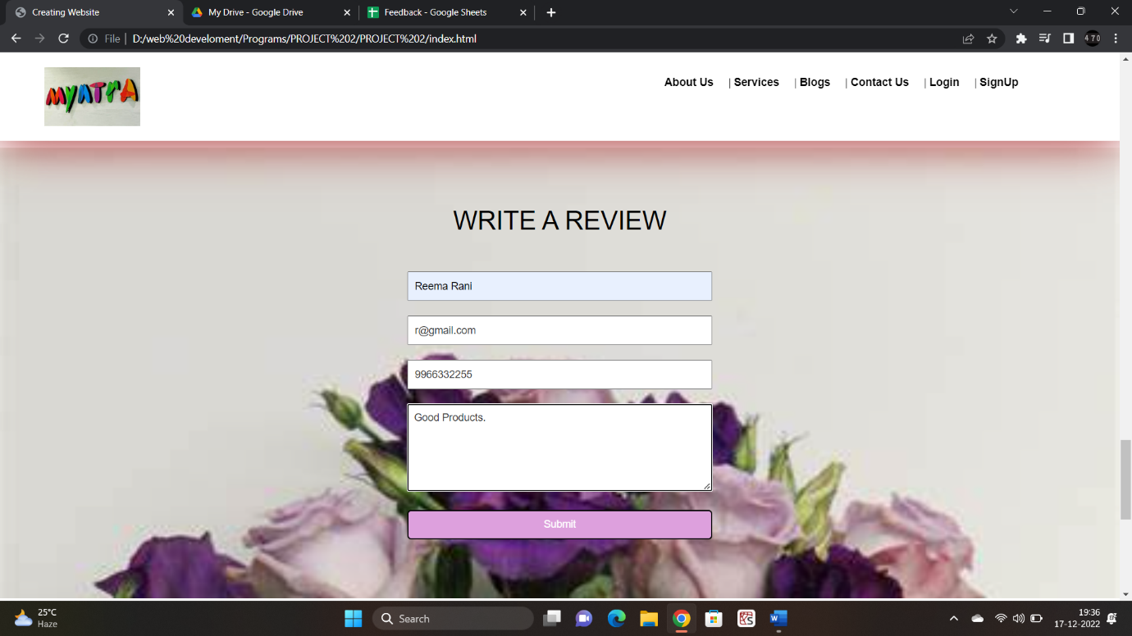

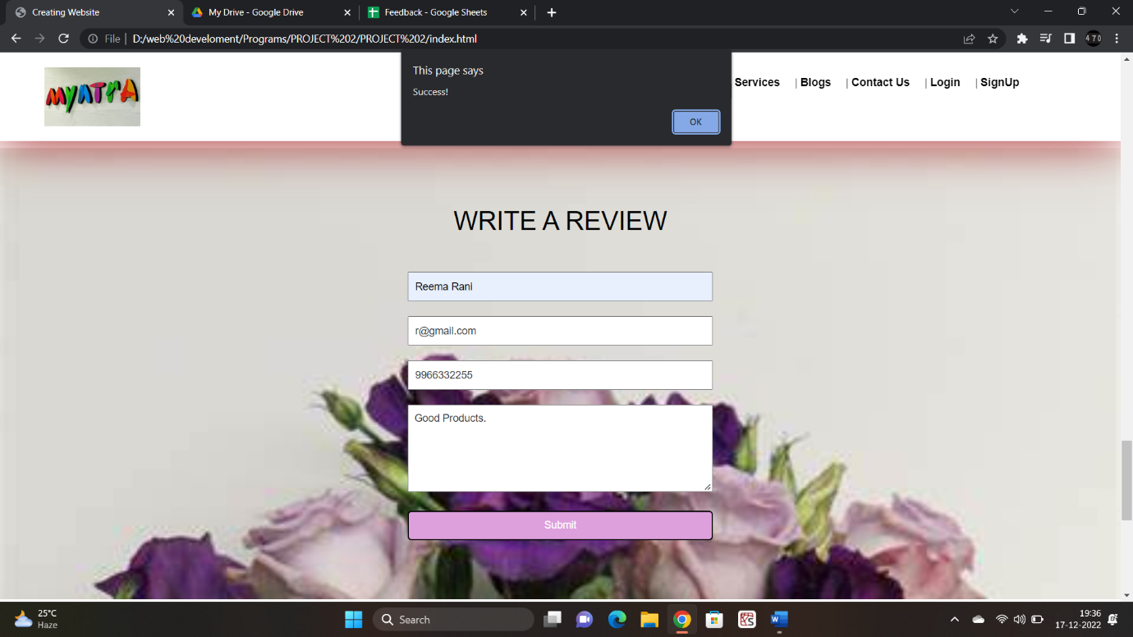

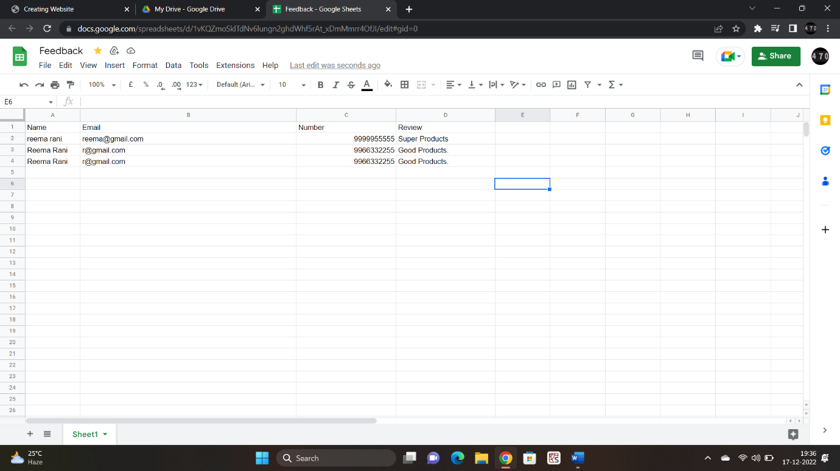

**9. Conclusion**

In a nutshell, this internship has been an excellent and rewarding experience. I can conclude that there have been a lot I’ve learnt from my work at the training &research centre. The technical aspects of the work I’ve done are not flawless and could be improved provided enough time.

As someone with no prior experience in JavaScript whatsoever I believe my time spent in training and discovering new languages was well worth it and contributed to finding an acceptable solution to an important aspect of web design and development. Two main things that I’ve learned the importance of are time-management skills and self-motivation. Although I have often stumbled upon these problems at university, they had to be approached differently in a working environment.

Working with web development languages has increased my interest in them, hence prompting me to transfer to the Web Design and Development course at my college.

**10. REFERENCES**

* <https://www.slideshare.net/JawharAli/training-report-on-web-developing>
* 1stop.ai classes